Oleander (Mitchell) Joseph

August 20, 1927 – March 2, 2008

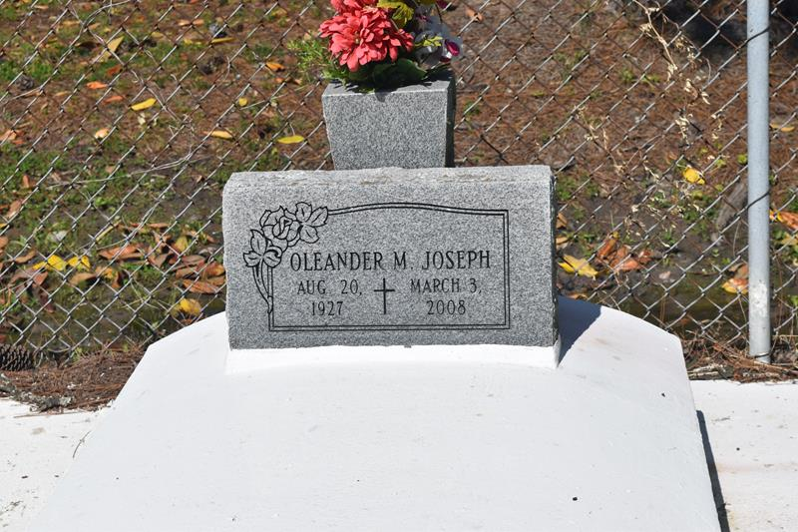

Oleander Mitchell Joseph, of Edgard, LA at her residence, on Monday, March 3, 2008 departed this life. Wife of the late Edward Joseph. Daughter of the late Sidney and Josephine Borne Mitchell. Sister of Christiana Pierre, Willie Mitchell, the late Herman, Simon, Ramos, Paul and Phillip Mitchell, Emily Augusta and Marie Edwards. Also survived by a host of nieces, nephews, cousins, other relatives and friends.  
  
Relatives and friends of the family, also pirest and parionsioners of the St. John the Baptist Catholic Church are invited to attend a Mass of Christian Burial on Friday, March 7, 2008 at 11:00 a.m. from the St. John the Baptist Catholic Church, 2361 Hwy. 18, Edgard, LA. Father Joel Cantones, celebrant. Visitation at the Church after 9:00 a.m. Interment Church Cemetery.  
  
THE BALONEY FUNERAL HOME, LLC, 399 Earl Baloney Dr., Garyville, LA 70051  
Information: (985) 535-2540 IN CHARGE OF ARRANGEMENTS

Times-Picayune, The (New Orleans, LA) - Thursday, March 6, 2008

Contributed by Jane Edson