Afton Julian

January 26, 1922 – November 28, 2001

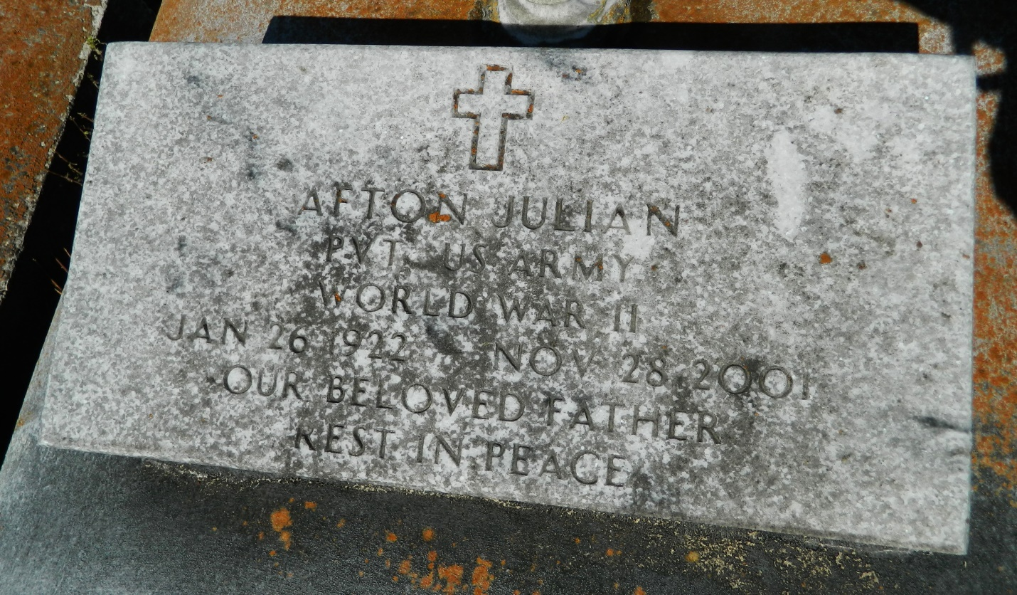

Bottom of Form

EDGARD - Afton Julian, 79, a native of Edgard and resident of Bridge City, died Nov. 28. He was the husband of the late Hilda Gerard Julian and father of Judy Russell, Linda Williams, Sandra Turner and Elliott Julian.

He was the son of the late Romalice and Margarite Samuels Julian and stepson of the late Nancy Julian. He is also survived by four grandchildren and one great-grandchild. Services are today at 10 a.m. at St. Joan of Arc Catholic Church, New Orleans, with interment at St. John the Baptist Cemetery, Edgard. Visitation begins at 8 a.m.

L'Observateur, LaPlace, LA; Dec. 1, 2001