Hilda (Gerard) Julian

May 23, 1929 – February 27, 2001

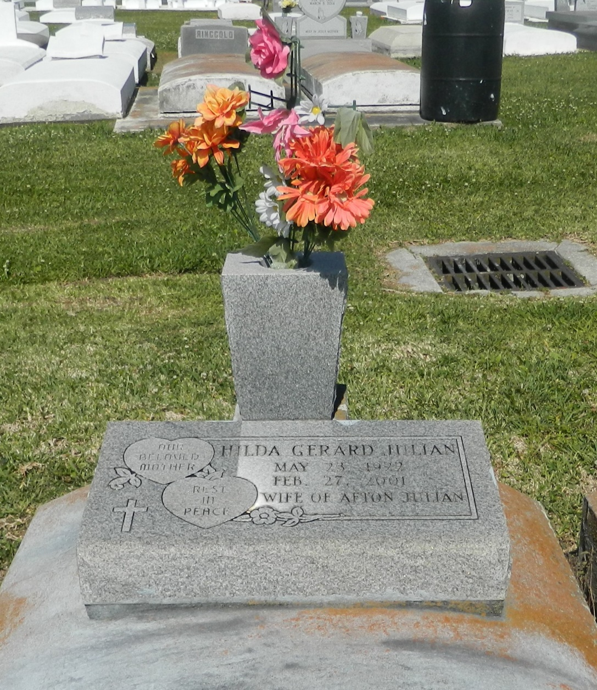

Bottom of Form

BRIDGE CITY - Hilda Gerard Julian, 78, a native of Lucy and resident of Bridge City, died Feb. 27. She was the wife of Alton Julian and mother of Linda Williams, Sandra Turner, Judy Russell and Elliot Julian. She was also the daughter of the late Arnold and Polemie Lebeouf Gerard and sister of Louise Legaux, Bernice Louper, Annabelle Weber and Joseph, Myrtle, Gladys

and the late Warren and Claude Gerard. She is also survived by three grandchildren and one great-grandchild. Services were March 2 at Holy Guardian Angels Catholic Church, Bridge City, with interment at St. John the Baptist Catholic Cemetery, Edgard.

L'Observateur, LaPlace, LA; March 03, 2001