Renet Elizabeth Julien

July 18, 1952 – December 22, 2008

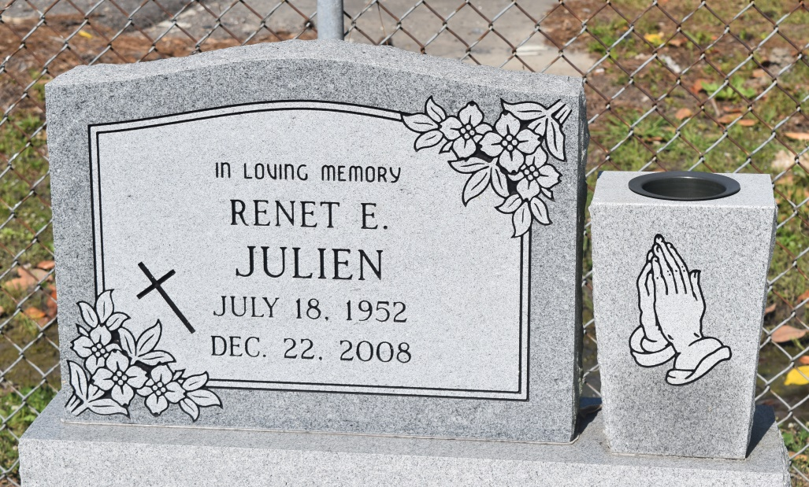

Renet Elizabeth Julien, at Canon Hospice, Jefferson, LA, on Monday, December 22, 2008. A native of Edgard, LA and a resident of Avondale, LA, departed this earthly life. Mother of Norma L. Earls, Jr. (Bridgette), Traves P. Earls (Crystal), and Kip M. Earls. Grandmother of Norman III, Paris and Nyeirr Earls and Jamal Lewis. Sister of John (Anna Mae), Eugene (Rose), Josephine Cureau (Orlyn), Anna J. Rainey, Ruby Fiffie (Roland), Cecile Lumar (Michael), Jacqueline Benoit (Terryel), Veronica Barnes (Nathaniel), Kurt Julien (Janet) and the late Preston Julien and Lillian Jackson. Preceded jn death by husband Norman L. Earls, Sr.; parents: Albertha Poche and Lawrence Julien. Survived by a host of nieces, nephews, sisters- and brothers-in-law, cousins, devoted friend, Evelyn Caldwell, other relatives and friends. Age 56 years.  
  
Relatives and friends of the family, also priest and parishjoners of St. John the Baptist Catholic Church, St. Bonaventure Church - Avondale, LA; employees of Suburban Extended Stay Hotel, Wynhoven Health Care, Priority Truck Service, Northrop Grunman, and Con Food Service are invited to attend a Mass of Christian Burial on Saturday, December 27, 2008 at 11:00 a.m. from the St. John the Baptist Catholic Church, 2361 Hwy. 18, Edgard, LA. Father Joel Cantones, celebrant. Interment Church Cemetery. Visitation at the Church after 9:00 a.m.  
  
The Baloney Funeral Home, L.L.C., 399 Earl Baloney Dr., Garyville, LA 70051, Information: (985) 535-8639 In Charge of Arrangements

Times-Picayune, The (New Orleans, LA) - Friday, December 26, 2008

Contributed by Jane Edson