Lula (Grice) LaGrange

March 3, 1951 – December 31, 2019

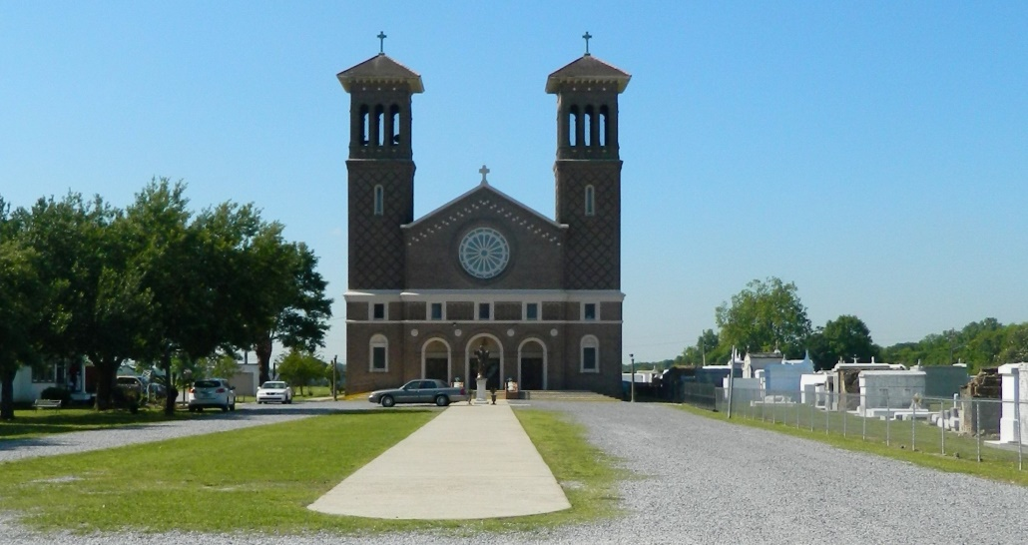

Lula Grice LaGrange born in Jacksonville, North Carolina on March 3, 1951. She was a resident of Gretna, Louisiana. Lula was called to our Lord in Heaven at the age of 68 on December 31st, 2019.  
 She is survived by her loving husband of 41 years Glenn Martin LaGrange of Edgard, Louisiana, Three children, Gloria Lewis Young, Leader DJai Lewis, and Desmond Wade LaGrange. Godmother to Devna Barkins-Mesley. Two Brothers, Howard Lee Grice of Boston, Massachusetts, and the late Marvin Everett Grice of Jacksonville, North Carolina. One Sister (Cousin), Renetta “Drew” Denton of Hempstead, New York. Two daughters-in-law, Porshe Outerbridge Lewis and Alleta Stiggers LaGrange. Thirteen grandchildren, Two great-grandchildren, and a host of precious loving nieces, nephews, cousins and an abundance of friends.   
 A Mass of Christian Burial will be held on Friday, January 10, 2020 at St John the Baptist Catholic Church, 2349 LA-18, Edgard, LA 70049, at 10:00 am. Visitation begins at 8:00 am. Interment at St. John The Baptist Catholic Church Cemetery. Final care has been entrusted to Treasures of Life Funeral Services, 315 E. Airline Highway Gramercy, LA 70052.

Treasure of Life Funeral Services, Gramercy, LA

Accessed 1/29/2020