Joseph Lanci

Abt. 1952 - October 13, 2018

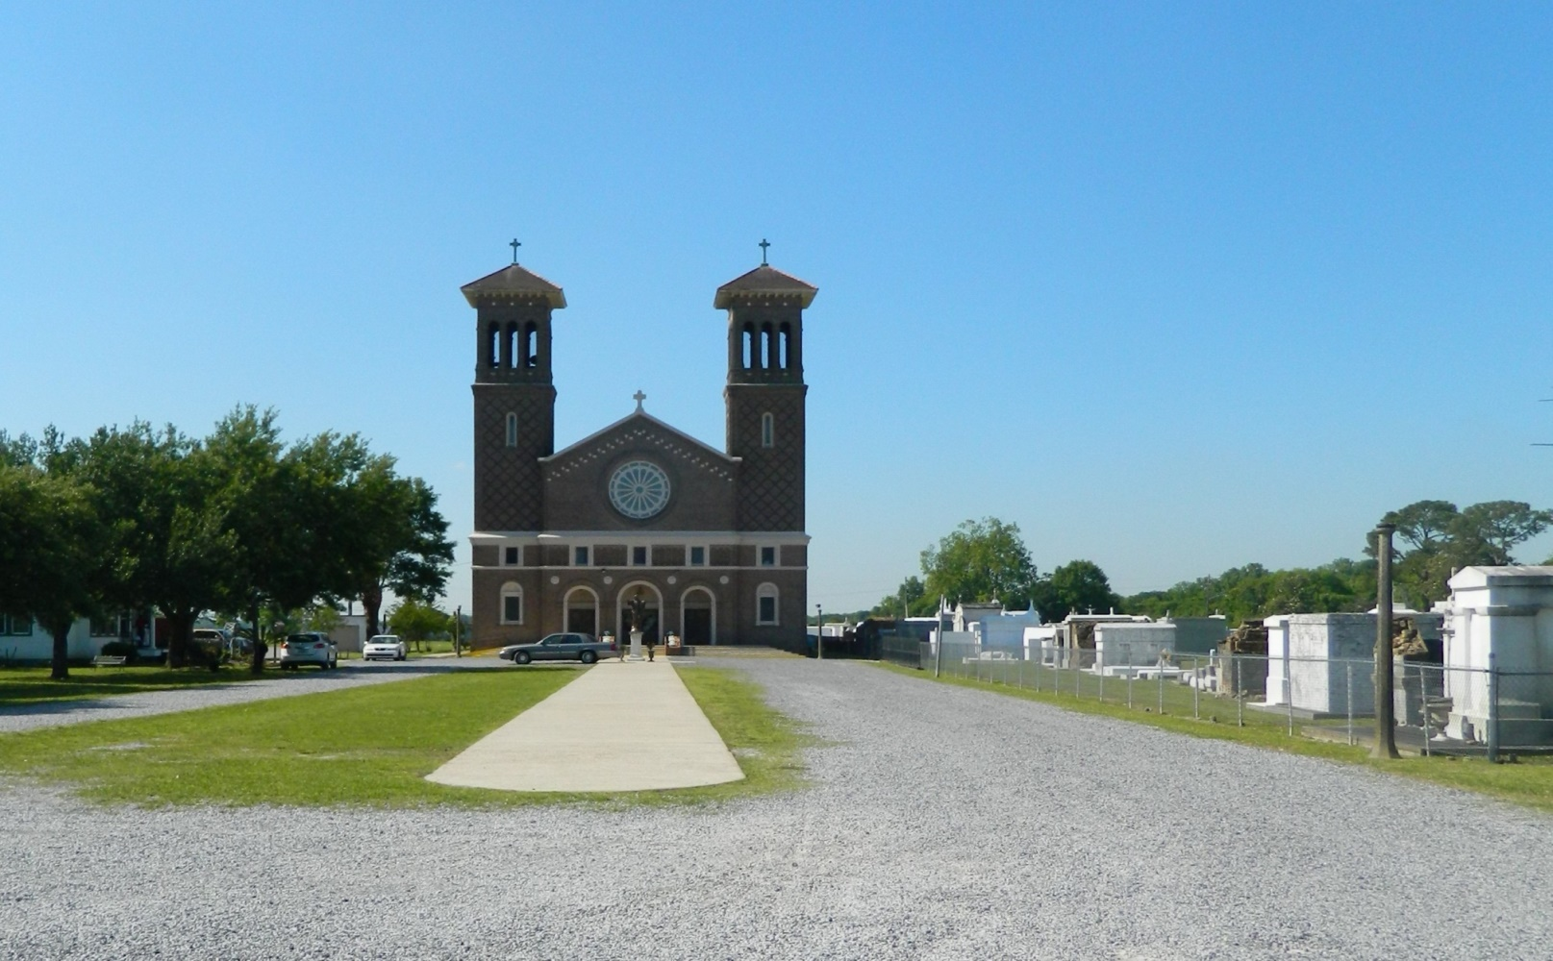

Joseph “Joe” Lanci passed away on Saturday, October 13, 2018 at the age of 66. He was a native of Mineola, New York and a resident of Luling, LA.

Beloved husband of Judy Madere Lanci. Father of Kimberly M. Lanci. Son of the late Mary Valsecchi Lanci and Albert Anthony Lanci. Brother of Richard Lanci (Nina) and Albert Lanci (Elaine). Brother-in-law of Joy Conrad (Tommy), Ray Madere, Ronald Madere and Janice Aucoin (Steve). Uncle of Gabriella Lanci, Brianna Lanci, Vincent Lanci, Miranda Conrad, Zoe Madere and Haley Madere.

Relatives and friends are invited to attend the Funeral Mass at St. John the Baptist Catholic Church, 2349 Hwy 18, Edgard on Thursday, October 18, 2018 at 11:30 a.m. Visitation at the church from 9:30 a.m. to 11:30 a.m. Interment in St. John the Baptist Cemetery. Arrangements by Millet-Guidry Funeral Home.

Millet-Guidry Funeral Home, LaPlace, LA (accessed October 17, 2018)