Shelia Ann (Webre) Landry

September 28, 1958 – January 19, 2006

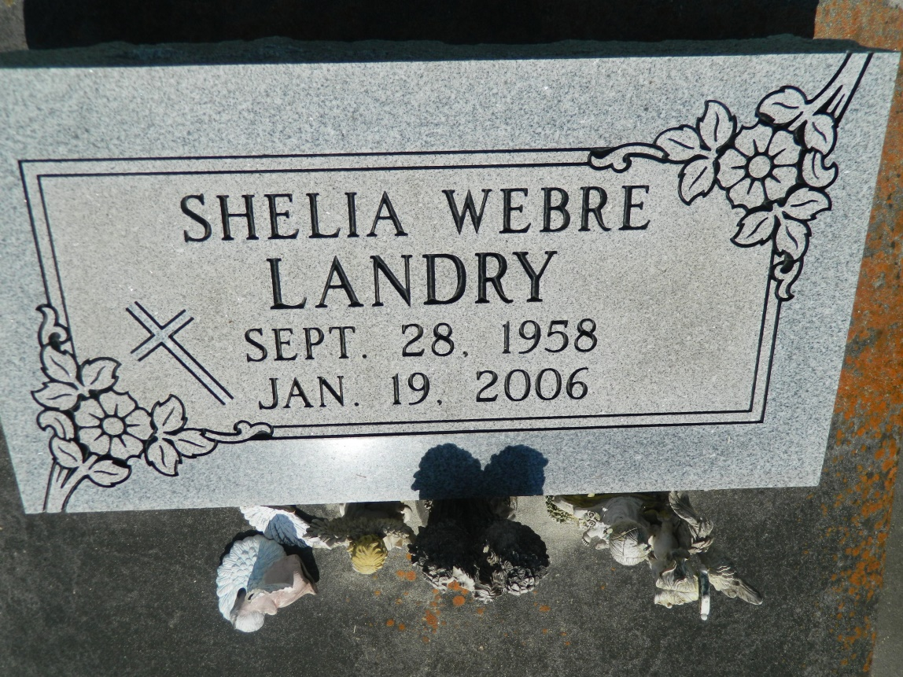

Shelia Ann Webre Landry, on Thursday, January 19, 2006 at 1 PM. Beloved daughter of Rene A. Webre and the late Anna Louise Webre. Former wife of Bruce Landry. Fiancee of Alton Vickers. Sister of Michael, Ralph, Rodney, Wayne, Bobby and David Webre, Catherine Cortez, Margaret Borne, Sarah Roberts, Sandry Cortez, Gail Bumgarden and the late Gary Webre. Also survived by 4 step children. Age 47. A native of Egard and a resident of Luling for the past 2 years.  
  
Relatives and friends of the family are invited to attend services. Visitation at St. John The Baptist Catholic Church, Edgard, LA. on Wednesday, January 25, from 9:30 AM til 12 noon. Followed by religious services at the church at 12 noon. Burial in church cemetery. Arrangements by Millet-Guidry Funeral Home, Laplace, LA.

Times-Picayune, The (New Orleans, LA) - Saturday, January 21, 2006

Contributed by Jane Edson