Irene (Oubre) LeGaux

May 30, 1914 – April 2, 2019

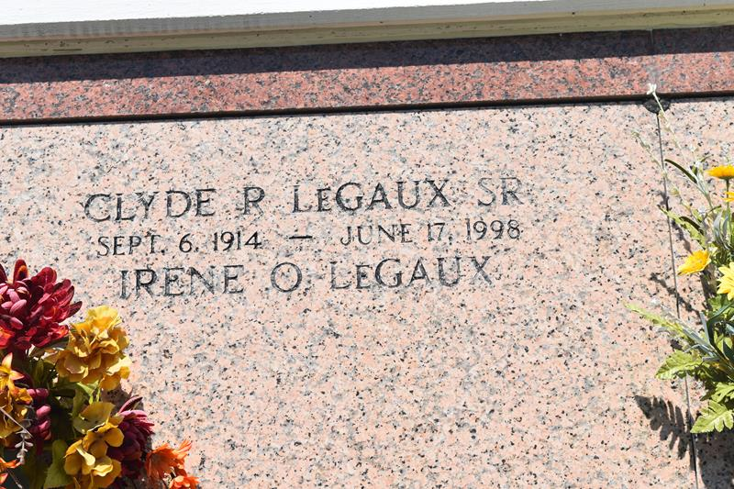

Irene O. LeGaux, affectionately known as "Miss Irene" devoted Christian, wife, mother, loving grandmother, great grandmother and great-great grandmother was called home to the arms of her Lord and Savior Jesus Christ on April 2, 2019 at the tender age of 104 years old, at her family home in Edgard, LA. She was born on May 30, 1914 in Vacherie, LA. to the late Andrew Oubre and Nellie Faucheux Oubre. "Miss Irene" was self-educated, a seamstress, farmer, carpenter, gardener and artist, a true renaissance woman. When the beautiful stained glass windows and statues at the Catholic Church caught her attention, she captured the likeness by designing pictures of the Saints and painfully collected scrap cloth and other materials found around the house to create works of art. She received an honorary high school diploma from St. John the Baptist Parish High School, a State-Approved Senior High School of Louisiana on May 31, 2014. She was a member of Knights of Peter Claver 4th Degree Ladies of Grace (Father John A. McShane, Chapter 23). She was also a member of Knights of Peter Claver Ladies Auxiliary Court 66 for over fifty years. In addition, she was a member of the Altar Society of St. John the Baptist Catholic Church of Edgard, LA. Irene was united in Holy Matrimony to Clyde Rene LeGaux, Sr. and they were blessed with four sons and three daughters of their fifty-six year union. "Miss Irene" was preceded in death by her late husband, Clyde R. LeGaux Sr., brothers; Sammy James, Andrew, John Arthur, Henry, and Paul Oubre. Sisters; Gertie Gautier, Archangel Goins, Elmira Duronslet, Agnelia Becnel and Marguerite Davis thus ending the long family lineage of Andrew and Nellie Oubre. Irene LeGaux was a loving and caring mother to seven children: Clyde Jr. (Deborah), Murphy Sr. (Linda), Donna Doublet, Van Sr. (Rose), Monna Mathieu (Larry), Carl LeGaux (Maria) and Sandra McCormick (Gilford). She is survived by 19 grandchildren, 47 great grandchildren, 2 great-great grandchildren and a host of nieces, nephews, family members and friends. The funeral services will be held on Saturday, April 6th, 2019 at St. John the Baptist Catholic Church, located at 2349 LA-18 in Edgard, La., officiated by Rev. Robustiano Morgia. 8AM viewing and 10 AM Mass, Interment immediately following at the Church Cemetery. Funeral arrangements entrusted to The Baloney Funeral Home, LLC located at 1905 West Airline Highway, LaPlace, LA. 70068 (985) 224-8460. Condolences may be offered at [www.baloneyfuneralhome.com.](http://www.baloneyfuneralhome.com/)

Legacy.com

accessed 1/30/2020