Viola Jean (Louis) Louis

November 13, 1935 - November 26, 2022

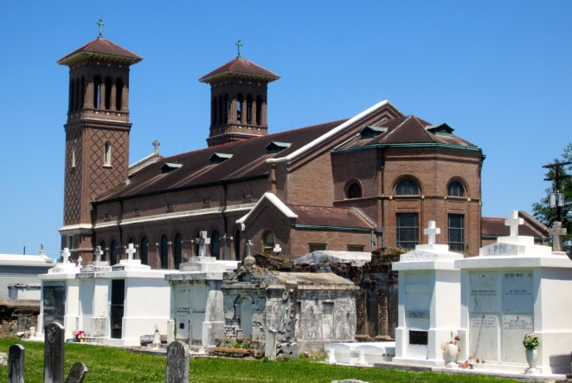

Viola Jean Louis was born on November 13, 1935, to the late Walter and Leona Harris Louis. On Saturday, November 26, 2022, at 1:55 pm, God summoned His angels to remove her from this earthly life. She passed away at her residence surrounded by her family.  
 Viola was baptized into the Catholic faith. She was a member of St. John the Baptist Catholic Church. She was most well known for her charming personality while working at The Boobie’s Food Store, where she made an everlasting impact on all who entered. She enjoyed hanging out at the Senior Citizen Center and playing bingo. Above all, she loved spending time with her kids, grandkids, and great-grandkids. She was always eager to gather on Sundays for a game party and a good meal. She was never a fancy cook, but she enjoyed making her specialties....red beans, rice custard, smothered potatoes, mustard greens, oatmeal, and eggs and rice. In her last days, she passed the torch to Mikalah to become the new eggs and rice queen.  
 Viola was married to Raymond J. Louis. From this union came Cynthia, Sandra, Beverly, Linda, Dolores, Marcia, Malcolm, Janice, Regina and Theresa.  
 On Saturday, November 26, 2022 Viola left this life of suffering to go home to her Lord and Saviour. She leaves to cherish her memory her children—Cynthia, Sandra, Beverly, Linda, Dolores, Marcia, Malcolm, Janice, Regina and Theresa; sons in law—James Lumar, Craig Harrison, Reginald Lumar, Darvie Thomas and Michael McIntosh; daughter in law—Dina Louis; sister—Jeanetta (Kernell) Butler; sister in law—Fabiola Louis; 20 grandchildren; 25 great grandchildren; 1 God child—Claudell Lumar Jr. and a host of nieces, nephews, cousins and friends.  
 Viola was preceded in death by her parents—Walter and Leona Harris Louis; husband—Raymond J. Louis; granddaughter—Latasha Lumar; sisters—Helen (Robert) Washington, Cecelia (Harry Sr.) Stipe, and Gloria (Daniel) Sloan; brother—Altis Louis; 1 son in law—James Gordon Sr.; sisters in law—Shirley (Cleveland) Lumar, Helen (Claudell Sr.) Lumar, Victoria Fiffie, and Lorraine (Ferdinand) Young; brothers in law—James (Ethel Mae), Herbert and Wilbert Louis; 2 nieces—Roxanne McDaniel and Lisa Roussell; 4 nephews—Andrew, Michael, Donald and Jeffrey Stipe.  
 A Mass of Christian burial honoring Viola Jean “Vi” Louis will be held on Saturday, December 3, 2022, at St. John the Baptist Catholic Church, 2349 La-18, Edgard, LA 70049. Visitation begins at 8 am. Recitation of Rosary at 9 am. Mass will begin at 10 am. Entombment to follow at St. John the Baptist Catholic Cemetery in Edgard, La. Final care and professional services entrusted to Treasures of Life Funeral Services, 315 E Airline Hwy., Gramercy, LA 70052.

Treasures of Life Funeral Services, Gramercy, Louisiana