Alex Joseph Lumar

January 20, 1931 – February 8, 2008

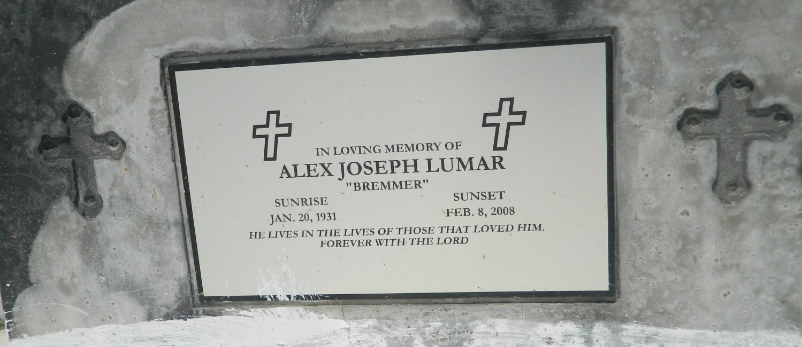

Alex Joseph (Brenner) Lumar of Edgard, La. on Friday, February 8, 2008 died at his residence in Edgard, La. Age 77 yrs. Son of the late Leo Paul and Albertine Lumar. Husband of the late Janice Jasmine Lumar. Father of Jerome Anthony (Carolyn) of Edgard, La. and Nolton Jude (Joyce) of Atlanta, Ga. Brother of Janetta, Eula and Ceola Lumar. Also survived by a host of grandchildren, 8 great grandchildren, sisters and brothers-in-law, nieces, nephews, cousins and friends.  
  
Relatives and friends of the family, also priest and parishioners of St. John the Baptist Catholic Church, New Jerusalem B.C., Greater Woodville B.C. and all neighboring churches, Employees of St. John Parish School System, St. John Parish Courthouse are invited to attend a Mass of Christian Burial on Saturday, February 16, 2008 at 11:00 AM from the St. John The Baptist Catholic Church, 2361 Hwy 18, Edgard, La. Father Joel Cantones celebrant. Interment Church Cemetery. Visitation at the church after 9:00 AM.  
  
The Baloney Funeral Home LLC, 399 Earl Baloney Dr., Garyville, La. 70051,   
985-535-2540

Times-Picayune, The (New Orleans, LA) - Friday, February 15, 2008

Contributed by Jane Edson