Jerry Lumar Sr.

July 22, 1950 - October 24, 2019

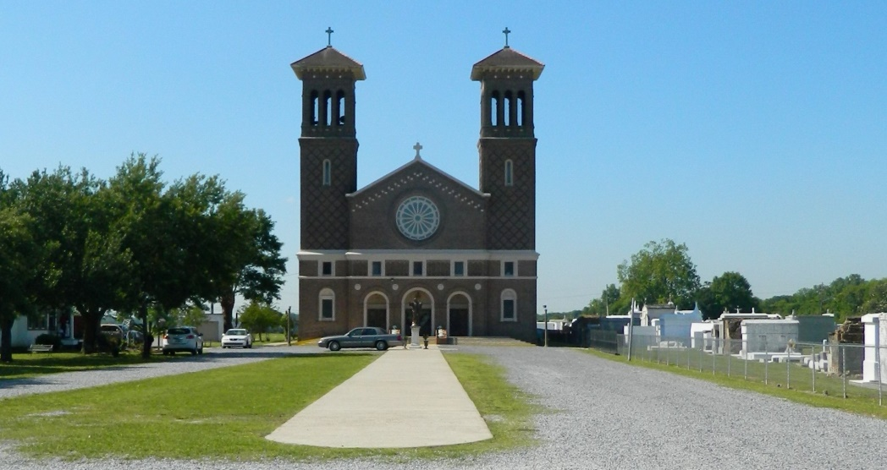

Jerry “Mule” Lumar, Sr., a lifelong resident of Edgard, La., passed away on October 24, 2019 at the age of 69. Jerry was born July 22, 1950 to the late Victor and Corrine Samuel Lumar.   
 Jerry is survived by his loving children, one son, Jerry (Kimberlee) Lumar of Forth Worth, Tx, two daughters, Juanier Lumar of Edgard, La. and Jovani Lumar of Destrehan, La., guardian of Andre Mitchell, three brothers, Carter (Lula) Lumar, Roger (Jacquline) Lumar, James (Loretta)Lumar, one sister, Stella (Keith) Mathieu of Edgard, La., six grandchildren, Jerrieal Lumar(Jimmy IV) Smalls, Jalayaha, Jazelle, Jahmad, Jordai and Jalana Lumar, one step grandson, Zaccheus Wyatt, two great-grandchildren, Nolan Price and Jimmy Smalls V, one godchild, Calvin Grows III and a host of nieces, nephews, family, and friends.  
 Jerry is preceded in death by his parents, Victor and Corrine Samuels Lumar and brother Gilbert Lumar.  
 All neighboring communities, churches, employees of Turner Industries, American Airlines, Rouses Supermarket, United States Postal Services, and Motiva are invited to attend the Mass of Christian Burial at St. John the Baptist Catholic Church, 2349 LA 18, Edgard, LA 70049, on Saturday, November 2, 2019 at 10 am. Visitation at 9 am until service time. Interment at St. John the Baptist Catholic Cemetery. Final care has been entrusted to Treasures of Life Funeral Services, 315 Airline Hwy, Gramercy, LA 70052.

Treasure of Life Funeral Services, Gramercy, LA

Accessed 1/29/2020