Mary Etta (Mitchell) Lumar

May 28, 1952 – December 3, 2019

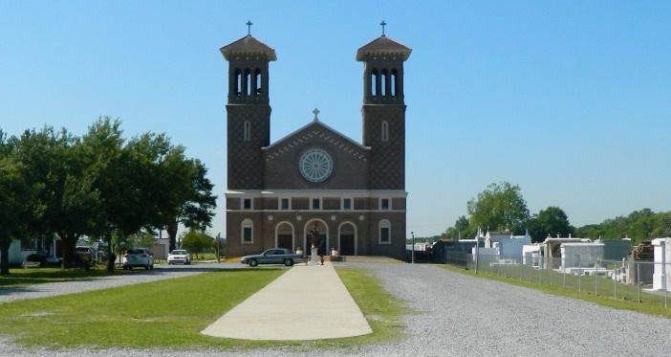

On May 28, 1952 Mary Etta Mitchell Lumar was born to Rev. Septem Mitchell, Sr. and Laura Becnel Mitchell. As the sixth of fourteen children, she was at the center of a loving and close-knit family. She shared her childhood with siblings: Anita, Celestine, Beulah, Jenny, Lorraine, Charlene, Septem, Jr., Roosevelt “Bobby”, Ronald, James, Sr., and Lester, Sr., Mary was a demure, elegant, and beautiful woman who caught the eye of her future brother-in-law’s cousin, Joseph “Boogie” Lumar. She was fifteen years old at the time. After a period of courtship, the two were wed on September 9, 1972. The following year, their union was blessed with the birth of their only son, Dana Joseph Lumar.  
 Mary was absolutely passionate about large family gatherings, annually celebrating Dana’s birthday, Easter, Halloween, and Christmas with the vast Mitchell and Lumar clans, neighbors, and friends. All looked forward to indulging in the star attraction of the festivities which was usually several of her magnificent cakes and muffins. The butt of many family jokes, Mary was also very fond of shopping, with Boogie often referring to her as the “QVC Queen”. On June 12, 2002 she was presented with her greatest joy and most favorite person to shop for: her granddaughter Direlle Michelle. She took immense pride and satisfaction in assisting Dana and Danielle with her Dirrie’s daily life.  
 Alas, on the morning of December 3, 2019, after a valiant and courageous battle with cancer, this beautiful soul was granted rest and called home. Mary leaves to cherish precious memories her son and daughter-in-law, Dana Joseph and Yolanda Thomas Lumar of Marrero; granddaughter Dirrelle Michelle Lumar of Laplace; step-grandsons Kyron and Brandon Rogers of Marrero; sisters Anita Lewis and Charlene Breaux (Kevin) of St. James, La, Celestine Steib (Ronald) of Vacherie, Jenny Wells (Raymond), and surrogate sister Dianne Hawkins of Harvey; brothers Septem Mitchell, Jr. (Betty) of Donaldsonville, Ronald Mitchell (Doreen) of Edgard, James Mitchell, Sr. (Judy) of St. James, and Lester Mitchell, Sr. (Terry) of Reserve; brothers-in-law Layn Morris, Whitney Lumar (Madeline), Davis Lumar (Roma), James “Kippy” Lumar (Edwina), and Allen Gauthier (Abby) all of Edgard; and sisters-in-law Patricia Populis (Freddie) of Edgard and Janet Favorite (Kanty) of Laplace, former daughter-in-law Danielle Harvey of Destrehan, several godchildren, numerous nieces and nephews, as well as a host of other relatives and friends.  
 She is preceded in death by her parents Rev. Septem, Sr. and Laura Becnel Mitchell, parents-in-law Ceola Lumar and Alvin Gauthier; sisters Beulah Morris and Lorraine Smith, brothers Roosevelt “Bobby”, David and Joseph Mitchell, brothers-in-law Leonard Smith, Fedorall Lumar, and Mark Gauthier, sister-in-law Barbara Dean Lumar, nephew Cory Mitchell, niece Denise Mitchell Dumas, great-nephew Tremaine Harrison, and great-niece Myrsadis Blackman.   
 A Mass of Christian Burial will be said Saturday, December 7, 2019 at St. John the Baptist Catholic Church at 2361 La. Hwy. 18, Edgard, La. 70049. Reverend Robustiano Morgia, Officiant. Visitation begins at 8:00 a.m. with services commencing at 10:00 a.m. Burial will be in the church cemetery. Final arrangements entrusted to Treasures of Life Funeral Services at 315 E. Airline Hwy., Gramercy, La. 70052. Repast to follow at West St. John Elementary School at 2555 La. Hwy. 18, Edgard, La. 70049.

Treasure of Life Funeral Services, Gramercy, LA

Accessed 1/29/2020