Catherine A. (Poche) Marshall

May 15, 1949 – Feb 17, 2012

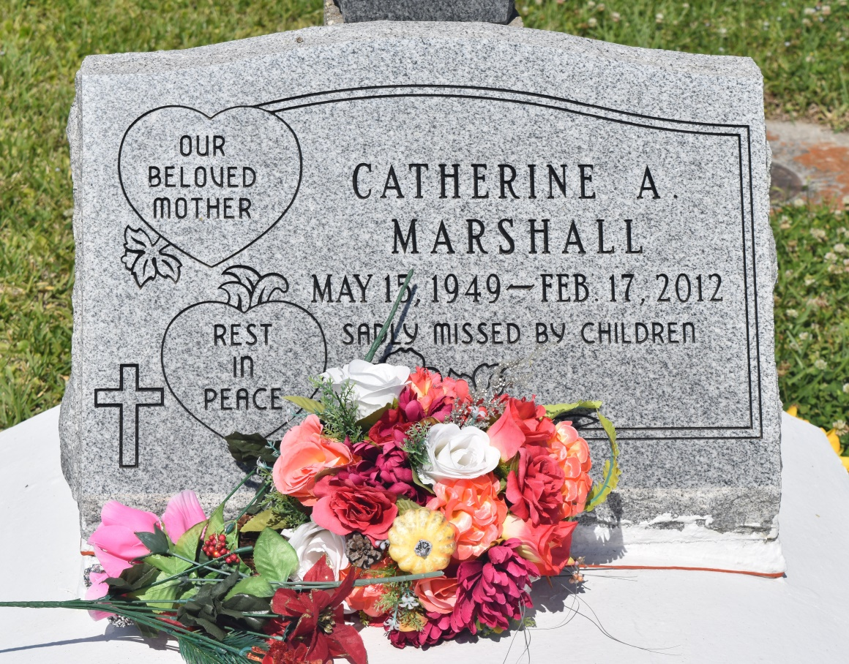

Catherine A. Marshall on Friday, February 17, 2012 at Ochsner of Kenner, Kenner, LA.  
  
Daughter of Caldonia Mitchell Poche and the late Clifton Poche, Sr. Mother of Kendall (Heather) Marshall and Natika (Victor) M. Bailey. Sister of Janet Pierre, Allen and Lionel Poche, Monica P. Swinney, and the late Charles and Clifton Poche, Jr. Grandmother of Teiana Marshall, Tramiya Keller and Raza'n Keller. Also survived by a host of nieces, nephews, cousins, other relatives and friends. Age 62 years. A native of Edgard, LA and a resident of Des Allemands, LA.  
  
Relatives and friends of the family, also priest and parishioners of Our Lady of the Holy Rosary Catholic Church and all neighboring churches are invited to attend the Funeral Mass at Our Lady of the Holy Rosary Catholic Church, One Rectory Lane, Hahnville, LA on Thursday, February 23, 2012 at 10:00 am. Father Bernard Francis Celebrant. Interment St John the Baptist Cemetery, Edgard, LA. Visitation at the above named church from 8:00 am until Mass time.  
  
SERVICED BY ROBOTTOM

Times-Picayune, The (New Orleans, LA) - Wednesday, February 22, 2012

Contributed by Jane Edson