Noah F. Mathieu

May 18, 1917 – May 29, 2001

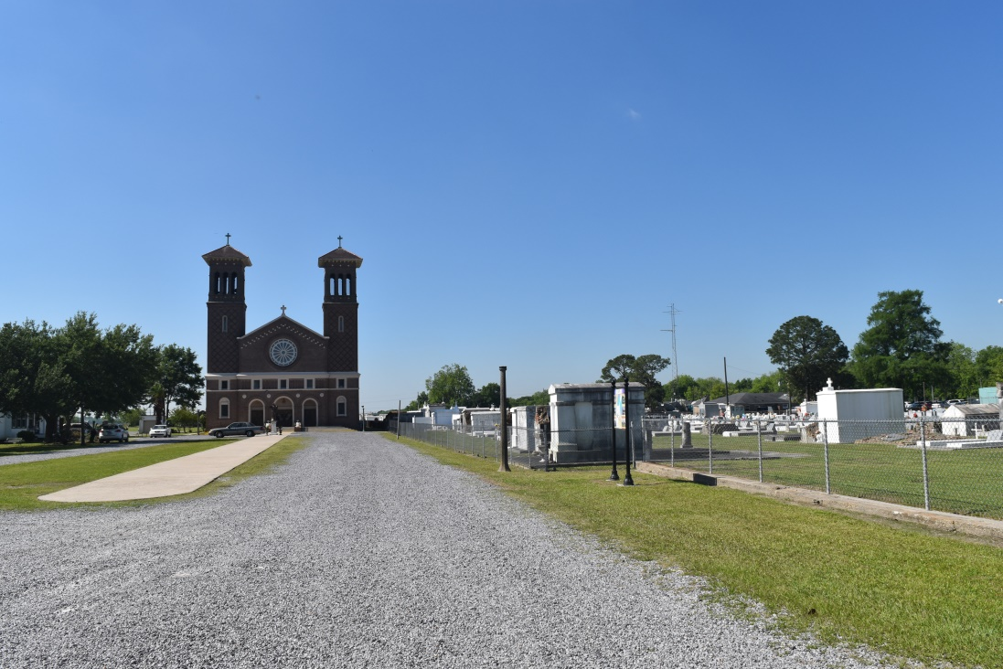

Noah F. "Chief" "Noway" Mathieu at Twin Oaks Nursing Home, LaPlace, LA on Tuesday, May 29, 2001. Husband of the late Melba Bartholomew Mathieu. Son of the late Carmel LeBeouf and Edgar Mathieu, Sr. Father of Larry J. Mathieu, Sr. of New Orleans, LA, Landry D. Mathieu of Kenner, LA, Keith R. Mathieu, Sr. and Karen A. Mathieu both of Lucy, LA. Brother of Roy J. Mathieu, Sr. of Bedford, Mass., Marie McCray of New Orleans, LA, Lorraine Alexis of Edgard, LA and the late Edgar Mathieu, Jr. Father-in-law of Monna L., Stella L. and Georgia B. Mathieu. Brother-in-law of Edna N. Mathieu, Arthemese J. Mathieu, Elmo J. Alexis, Hilda B. Roussel, and the late Kado C. McCray, Murial B. Williams, Ruth B. Simon, and Nathan Bartholomew. Uncle of Ivy and Kim Mathieu, Roy J. Mathieu, Jr. and the late Lennaire C. Alexis. Grandfather of Larry Mathieu, Jr., Landry Mathieu, Jr., Damon Mathieu, Mark Mathieu, Keith Mathieu, Jr., and Gerren Mathieu. Also survived by a host of nieces, nephews, other relatives and friends. Age 84 years. A native and resident of Lucy, LA.  
  
Relatives and friends of the family, also priest and parishioners of St. John the Baptist Catholic Church and all neighboring churches and employees of Dupont Pontchartrain Site, Dupont Dow Elastomers, Aircraft Service International Group, Northorp/Avondale, Monsanto/H.B. Zachry and Twin Oaks Nursing Home are invited to attend the Mass of Christian Burial at St. John the Baptist Catholic Church, River Road, Edgard, LA on Saturday, June 2, 2001 at 10:00 A.M. Father Vincent Qui, Celebrant. Interment St. John the Baptist Cemetery, Edgard, LA. Visitation at the church from 8:00 A.M. until Mass time.  
  
Serviced by Robottom.

Times-Picayune, The (New Orleans, LA) - Friday, June 1, 2001

Contributed by Jane Edson