Herman Mitchell Jr.

1957 – May 25, 2018

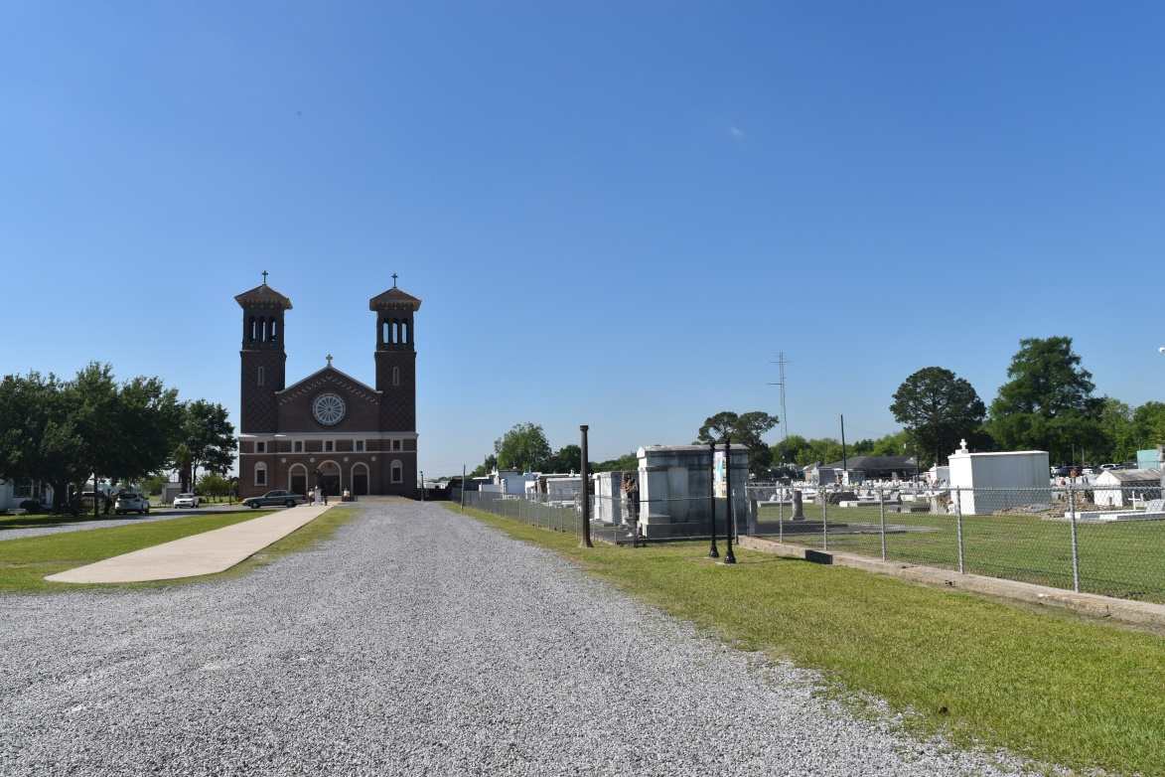

Herman 'Beaver" Mitchell Jr. entered into eternal rest on Friday May 25, 2018 at Ochsner Medical Center in Kenner, LA. following a brief illness.  
 Son of the late Herman Mitchell Sr. and Girlie Brooks Mitchell. Husband of Jacqueline K. Mitchell and Loving Father of Latoya Mitchell Weston, Brandon Mitchell, and Latischa Keller. Father-in-Law of Ryan T. Weston and Alana Thomas Mitchell, Brother of Mary Mitchell & the late Beverly M. Lumar. Left to cherish his memories are his beloved 9 grandchildren, nieces, nephews, cousins, and close friends.  
 He was born in Edgard, Louisiana, and was a resident of LaPlace, La. and retiree of Archer Daniels Midland, and former employee of Avondale Shipyard. His passions included fishing, cooking, and being surrounded by family and friends.  
 Funeral service to be held on Saturday June 2, 2018 at St. John the Baptist Catholic Church 2349 Hwy. 18, Edgard, La. 70049 at 10:00a m. Father Robustiano Morgia celebrant.  
Viewing starts at 8:30 am and Rosary to be held at 9:00 am.  
 Services to be entrusted to Treasures of Life Funeral Services, 315 E. Airline Hwy., Gramercy, La.

Treasures of Life online obituary (accessed 6/19/2018)