Marie Antoinette (Schexnayder) Moll

October 13, 1945 – July 22, 2015

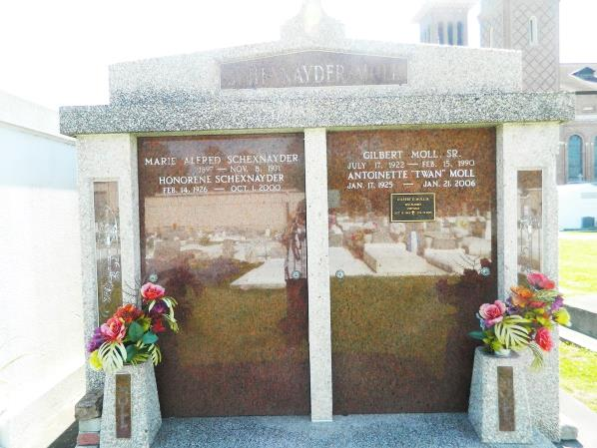 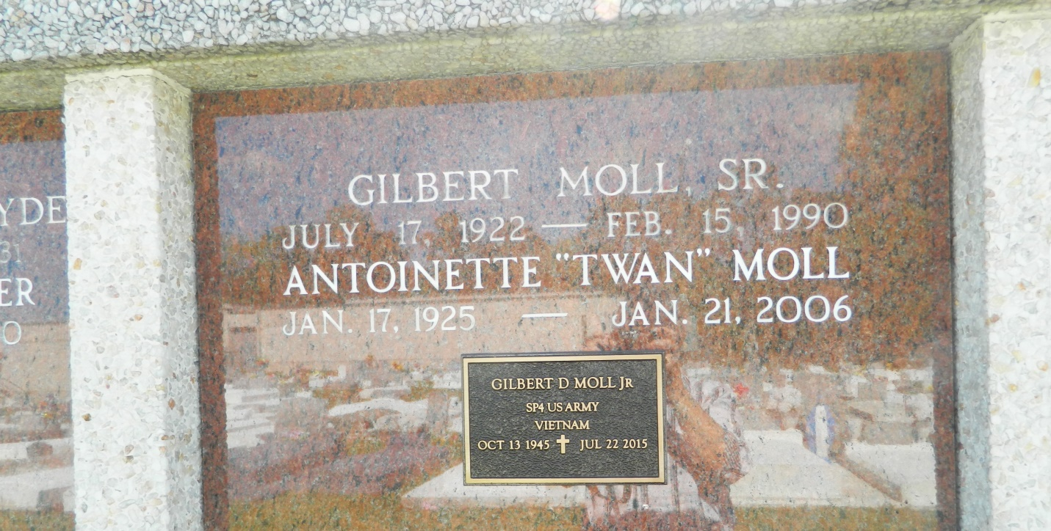

Marie Antoinette (Twan) Moll of Edgard, La. on Saturday, January 21, 2006 at Thibodaux Regional Medical Center. Daughter of the late Marie and Walton Schexnayder. Wife of the late Gilbert Moll. Sr. Mother of Gilbert Moll, Jr. (Gloria), Edgard, La. Sister of Gertrude Johnson, Edgard, La. and the late Honorene, Walter, Raymond, Warren, Roland and Clarence Schexnayder. Grandmother of Kevin (Misty) of Chickasha, Oklahoma, Brian, Kimberly (Carlo) of Edgard. Also survived by 5 great grandchildren, a host of nieces, nephews, cousins and friends. A native and resident of Edgard, La. Age 81 years.  
  
Relatives and friends of the family, also Priest and Parishoners of St. John the Baptist Catholic Church; employees of Gil's Restaurant and Catering are invited to attend a Mass of Christian Burial on Tuesday, January 24, 2006 at 11:00 A.M. from the St. John the Baptist Catholic Church, Edgard, La. Father Joel Cantones, Celebrant. Interment Church Cemetery. Visitation at the church after 9:00 AM.  
  
The Baloney Funeral Home L.L.C., 399 Earl Baloney Drive, Garyville, LA. 70051,   
(985) 535-2540 In Charge of Arrangements.

Times-Picayune, The (New Orleans, LA) - Monday, January 23, 2006

Contributed by Jane Edson