Gilbert David Moll Jr.

October 13, 1945 – July 22, 2015

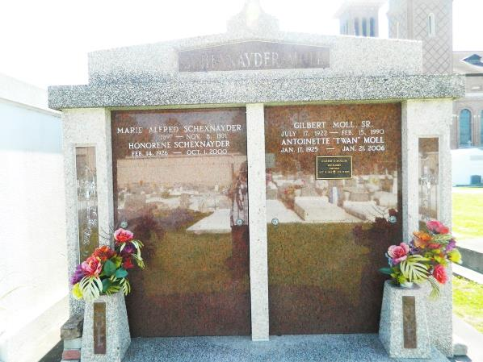 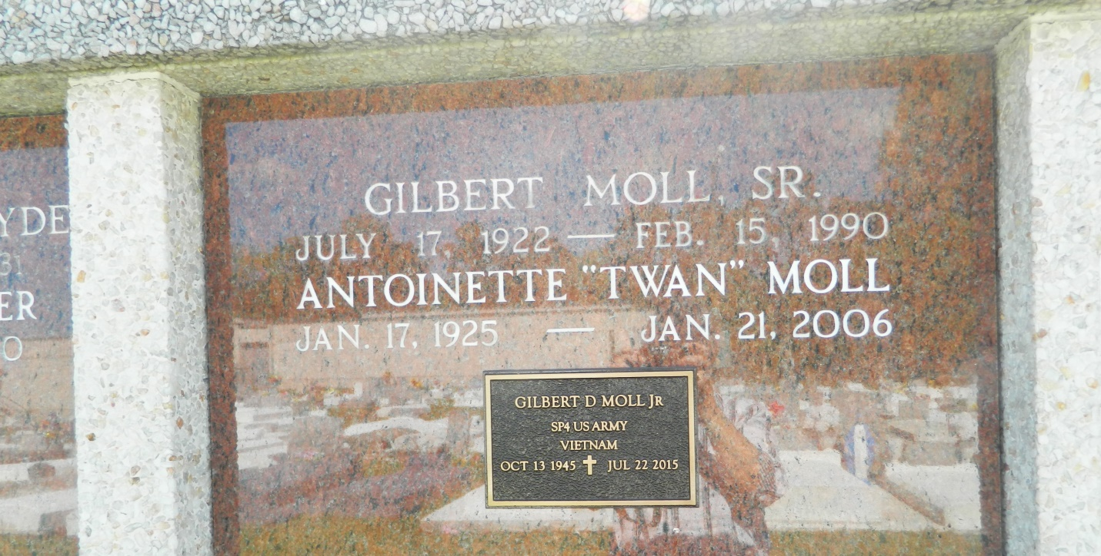

Gilbert David "Pee Wee" Moll, Jr., a resident of Edgard, La., passed away Wednesday, July 22, 2015, at the age of 69. Gilbert was a Vietnam War Veteran who served in the United States Army. Past owner of Gil's Restaurant for over 30 years. Son of the late Marie Antoinette and Gilbert Moll, Sr. Beloved husband of Gloria H. Moll. Father of Kevin Moll (Anita Willms) of Kingfisher, Oklahoma, Brian Moll, and Kimberly (Carlo) Savoie. Grandfather of Sierra Villegas, Khalid Moll, Kyrin, Carlie, and Kolbie Savoie. Nephew of Delores Moll. Also survived by a host of nieces, nephews, cousins, other relatives, godchildren and special friends.  
  
Funeral services will be held at The Baloney Funeral Home, LLC, 1905 W. Airline Highway, Laplace, La., on Tuesday, July 28, 2015 for 11:00 a.m. Visitation will be from 9:00 a.m. until time of service. A separate viewing will be held at the Baloney Funeral Home, LLC, on Monday, July 27, 2015 from 2:00 p.m. until 5:00 p.m. Pastor Frank Johnson will be officiating. Private burial. Employees of St. John Parish School System, Staff of VA Primary and Specialty Care Clinics, Southeast LA War Veterans Home, Ochsner Kenner Hospital and Clinic, and Hospice Compassus Care Services are invited to attend the funeral services. Care of my husband was entrusted only to the professionalism of The Baloney Funeral Home, LLC, 1905 W. Airline Highway, Laplace, La., 985-224-8460. Condolences can be express [www.baloneyfuneralhome.com](http://www.baloneyfuneralhome.com/).

Times-Picayune, The (New Orleans, LA) - Sunday, July 26, 2015

Contributed by Jane Edson