Gloria J. Pierre

February 11, 1945 – December 14, 2002

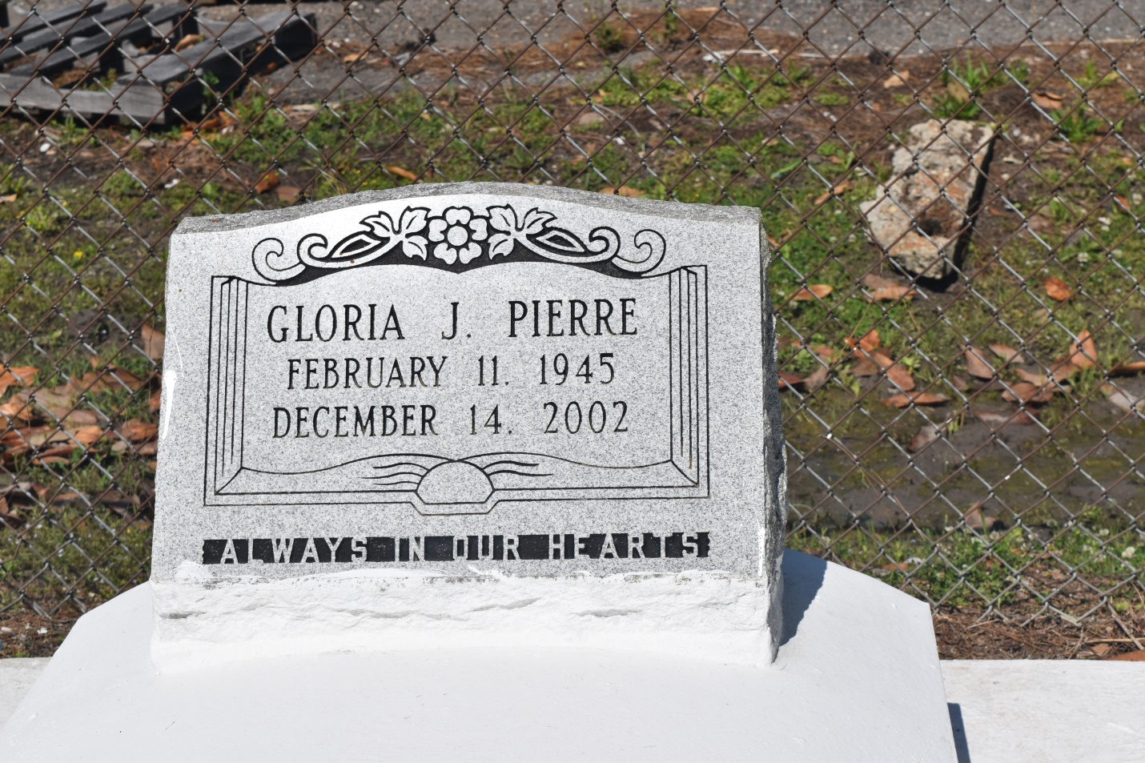

Gloria Pierre, a homemaker, died Saturday of a heart attack at St. James Hospital. She was 57. Mrs. Pierre was a lifelong resident of Edgard. Survivors include a daughter, Donna Lynn Pierre; two sons, Vincent and Damian Pierre; a brother, Warren Pierre; a sister, Rose Morrison of Avondale; and three grandchildren. She was the legal guardian of Zedra Charles of Harvey and Greta and Renata Franklin of Edgard.

A Mass will be said Saturday at 10 a.m. at St. John the Baptist Catholic Church in Edgard. Visitation will begin at 8 a.m. Burial will be in the church cemetery. The Baloney Funeral Home is in charge of arrangements.

Times-Picayune, The (New Orleans, LA) - Friday, December 20, 2002

Contributed by Jane Edson