Pearl (Meadoux) Pierre

April 1, 1923 – March 17, 2014

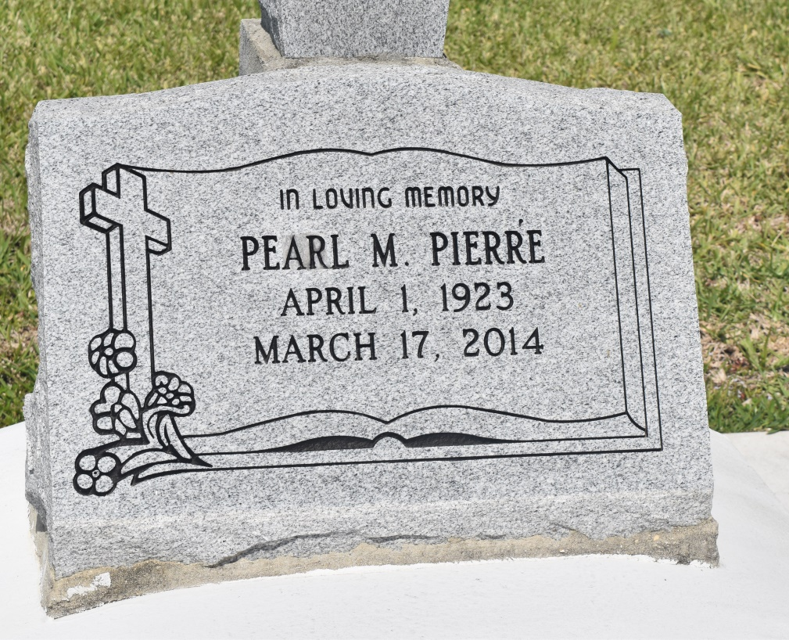

PEARL PIERRE on Monday, March 17, 2014 at her home in Edgard, LA.  
  
Daughter of the late Louise Sorapuru and Nelson Meadoux. Wife of the late Herman Pierre. Stepmother of Ida Pierre and Steven Pierre Sister of Alice Miller, the late Zenobia Augusta, Noelia Gauthier, Lester Meadoux and Louis Meadoux. Also survived by 2 step grandchildren and a host of nieces, nephews, cousins, other relatives and friends. Age 90 years. A native and resident of Lucy, LA  
  
Relatives and friend of the family, also priest and parishioners of St John the Baptist Catholic Church and all neighboring churches are invited to attend the Funeral Mass at St. John the Baptist Catholic Church, 2361 Highway 18 (River Road), Edgard, LA on Friday, March 21, 2014 at 11:00 AM. Father Robustiano Morgia, Celebrant Interment St. John the Baptist Cemetery, Edgard, LA. Visitation at the above named church from 9:00 AM until Mass time. Rosary at 10:00 AM  
  
SERVICED BY ROBOTTOM

Times-Picayune, The (New Orleans, LA) - Wednesday, March 19, 2014

Contributed by Jane Edson