Tamara Denise "Tam" Roybiskie

August 28, 1973 - December 27, 2019

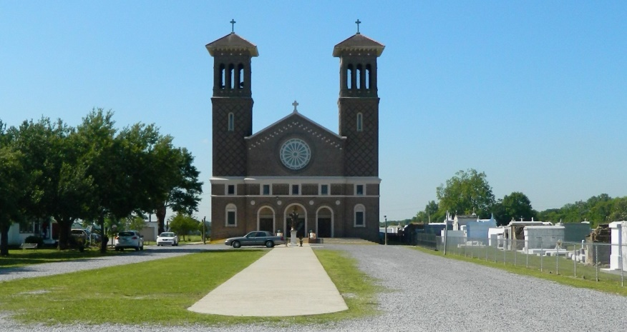

On Thursday, December 26, 2019, Tamara Denise Roybiskie, loving daughter, mother, sister, aunt, and friend, passed away at the age of 46. Tamara was born on August 28, 1973, in Thibodaux, LA. She was a graduate of West St. John High School and Louisiana Technical College. She was an employee of ExxonMobil for 18 years.   
 Tamara was a faithful parishioner of St. John the Baptist Catholic Church where she taught catechism and sang in the church choir for more than three decades. She was also the creator and organizer of the church’s annual Family Day Celebration. Tamara had a passion for singing, line dancing, and Disney World. She always said she could live on a Disney cruise. Most of all, Tamara loved to plan events for family and friends. She was her happiest when planning a birthday party or family gathering.   
 Tamara is survived by her parents, Donnie and Chermaine Roybiskie, her daughter, Jasmine Stewart, her siblings, Farrah and Donnie Roybiskie, Jr., her niece and nephew, Lauryn and Brandon Roybiskie, along with a host of aunts, uncles, cousins, and friends.   
 A Mass of Christian Burial will be held on Saturday, January 4, 2020 at St. John The Baptist Catholic Church, 2349 LA-18, Edgard, LA 70049 at 10:00 am. Visitation begins at 8:00 a.m. Entombment at St. John The Baptist Catholic Church Cemetery. Final care has been entrusted to Treasures of Life Funeral Services, 315 E. Airline Highway Gramercy, LA 70052.

Treasure of Life Funeral Services, Gramercy, LA

Accessed 1/29/2020