Lorita (Miller) Savoie

August 19, 1932 - April 3, 2020

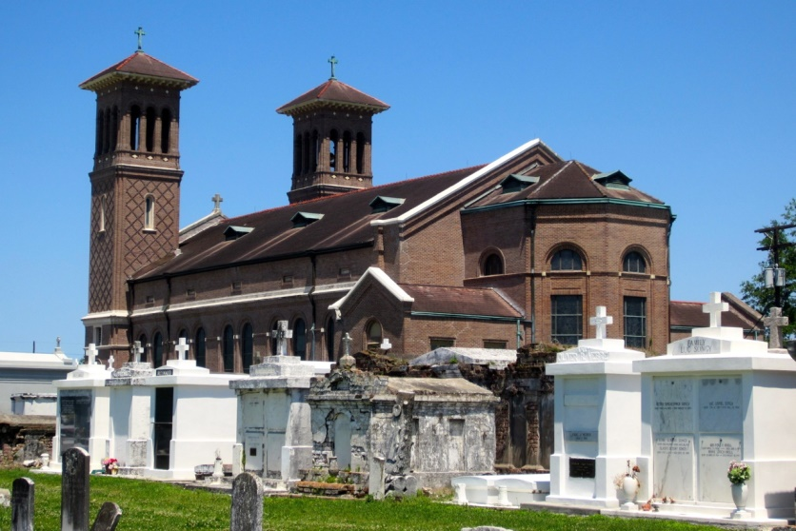

On April 3, 2020, Lorita Miller Savoie sweetly surrendered her soul to God at the age of 87 at her residence in Edgard, LA. Lorita was the daughter of the late Oscar Miller and Bertha Burke Miller. Dearly known to most as “T-Reat” or “Lo”.  
 Lorita was born and raised in Edgard, LA and resided there her entire life. On August 18, 1951 Lorita untied in holy matrimony to Joseph Blaine Savoie Jr. to this union seven children were born: Marcia, Craig, Wanda, Tania, Rodney, Greta and Dale.  
 Lorita was a faithful and lifelong member of St. John the Baptist Catholic Church, where she served as a Eucharistic Minister and a member of the Altar Society. She was a dedicated member of the Knights of Peter Claver Ladies Auxiliary Our Lady of Perpetual Help Court #66 and served as Grand Lady for thirty-five years. She was also a charter member of the Knights of Peter Claver Ladies of Grace- Father John A. McShane chapter 23, and served as the navigator for six years.  
 Lorita was known for her generous acts of kindness and great cooking skills. She loved serving her community, Council on Aging and her Senior Citizen club. She believed in lending a hand to whomever desired her services. She retired as a nurse’s aid from Ochsner and St. Charles hospitals. She also worked at St. Philip Catholic Church rectory.  
 Lorita leaves her loving family to honor and cherish her memories: Marcia (Andree) Medlin, Craig (Joyce) Savoie, Tania Alexander, Rodney Savoie, Greta (Perry) Boudoin, and Dale (Essue) Savoie; nine wonderful grandchildren: Carlo, Latasha, Brittany, Ashley, Erin, Elana, Andree, Christopher and Chelsea. She also cherished thirteen great-grandchildren; loving sisters Rosalie M. Donald and Carol M. Adams; sisters-in-law Mathilda S. Smith, Jeanette W. Savoie of New Orleans,LA and Ernestine T. Savoie of Reserve, LA; brothers-in-law Charles Savoie of New Orleans, LA, Jerry Savoie of Reserve, LA, Paul August, Daryl Adams and Raymond Bailey of Edgard, LA; Godchildren Soundra Johnson, Ingrid Barnes, Tyrone Edwards, Shawn Hall and Belinda Hall; and a host of relatives and friends.  
 She is preceded in death by her husband: Joseph B. Savoie Jr., daughter: Wanda Savoie, father: Oscar Miller, mother: Bertha Burke Miller, father-in-law: Blaine Joseph Savoie, mother-in-law: Beulah Borne Savoie; sisters: Vivian M. Allen, Irene M. Bailey and Audrey M. Hall; brother: Sterling Miller; sisters-in-law: Etehl S. Savoie, Ernestine S. August, Lucretia S. Briscoe, Carolyn S. Grant, Alma S. Johnson and Vivian Miller; brothers-in-law: Timothy Donald, McKinley Savoie, Alfred Grant Sr., Harold Briscoe Sr., Bartholomew Johnson Jr. and Lawrence Smith Sr.

Treasures of Life Funeral Home, Gramercy, LA

April 11, 2020