Honorine Schexnayder

February 14, 1926 – October 1, 2000

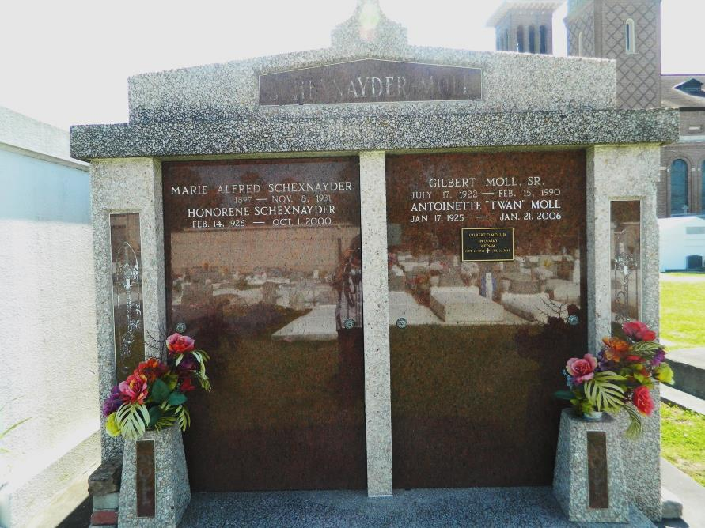

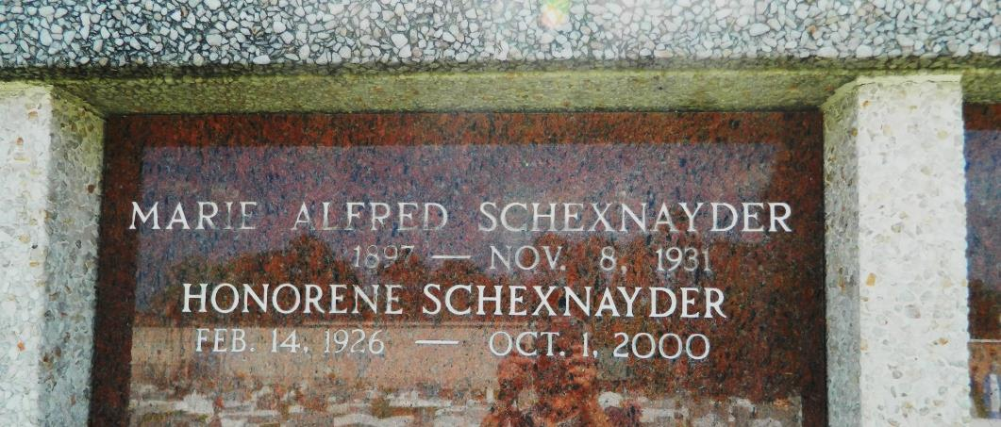

EDGARD - Honorene Schexnayder, 74, a native of Edgard and resident of New Orleans, died Oct. 1. She was the mother of Lorraine Boyd. She was also the daughter of the late Walter and Marie Alfred Schexnayder and sister of Antoinette Moll, Gertrude Johnson and Walter, Raymond and the late Clarence, Roland and Warren Schexnayder. She is also survived by one grandchild.  
 Services were Oct. 6 at St. John the Baptist Catholic Church, Edgard, with interment at the church cemetery.

L'Observateur (La Place, LA) - Saturday, October 7, 2000

Contributed by Jane Edson