Alphonse Joseph Simon Jr.

November 1, 1942 – June 22, 2004

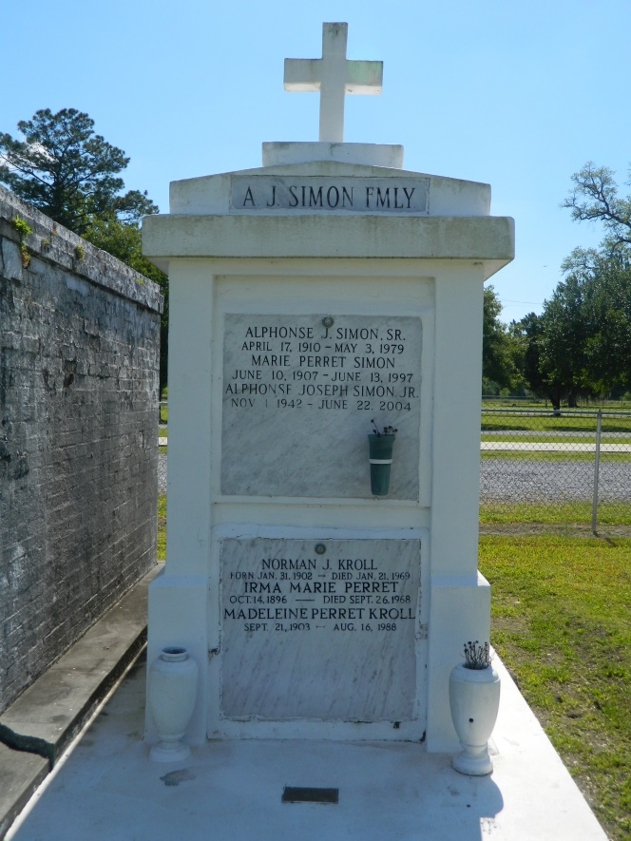 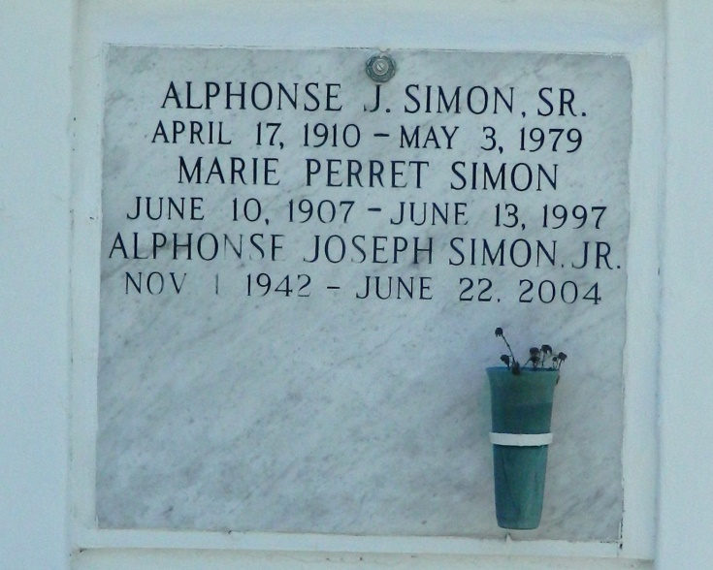

Alphonse Joseph "A.J." Simon Jr., a rental and used equipment manager with Briggs Equipment, died Tuesday of pancreatic cancer at his home. He was 61. Mr. Simon was born in Edgard and lived in Metairie for the past 38 years. He was a parishioner of Saint Mary Magdalen Catholic Church. He was a veteran of the Army Reserve.

Survivors include his wife, Brenda Songy Simon; two sons, Troy Anthony and Todd Gerard Simon; a daughter, Lorraine S. Braden and Miriam S. Costes; and four grandchildren.

A Mass will be said Friday at noon at St. John the Baptist Catholic Church, 2349 Louisiana 18, Edgard. Visitation will begin at 9 a.m. Burial will be in the church cemetery. Alexander Funeral Home is in charge of arrangements.

Times-Picayune, The (New Orleans, LA) - Thursday, June 24, 2004

Contributed by Jane Edson