Herbert Smith

Abt. 1947 – August 29, 2017

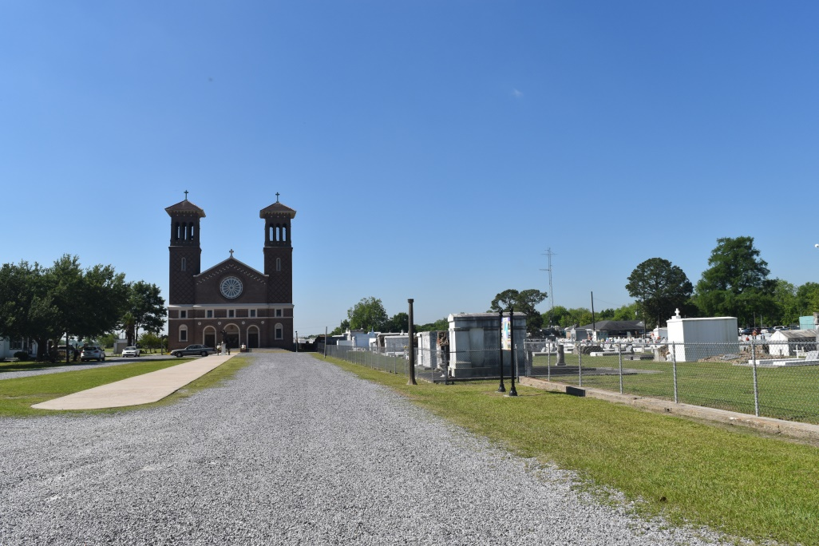

Herbert "Boo" Smith, Sr. "Educator" on Tuesday, August 29, 2017 in Edgard, LA. Son of the late Belmont Smith and Mary Percy Smith. Husband of Gloria C. Smith. Father of Herbert Smith, Jr. Brother of Lester B. Smith (Janice) and Shelton Smith (Sandra). Devoted friend and business partner of Haston "Lipper" Lewis. Nephew of Barbara Smith of Chicago, IL and Lynn Townes of Detroit, MI. Also survived by a host of cousins, other relatives and friends. Age 70 years. A native and a resident of Edgard, LA. Relatives and friends of the family, also pastors, officers and members of Greater New St Peter Baptist Church and all neighboring churches, Employees of St John the Baptist Parish Public School System, St John and St James Retired Teacher Associations, Southern University River Parish Quarterback Club, Second Ward class of 1965 and Knights of Peter Claver Council #65 are invited to attend the Funeral Service at Greater New St Peter Baptist Church, 200 West Third Street, Edgard, LA on Saturday, September 2, 2017 at 11:00 AM. Rev. Vernon Alexander, Pastor, Officiating. Entombment St John the Baptist Catholic Church Cemetery, Edgard, LA. Visitation on Friday, September 1, 2017 at Bethlehem Baptist Church, 146 E. 20th Street, Reserve, LA from 4:00 PM - 7:00 PM and again on Saturday, September 2, 2017 at the above named church from 8:00 AM until Service Time. SERVICED BY ROBOTTOM

Published in The Times-Picayune on Sept. 1, 2017

Legacy.com (accessed 6/19/2018)