Noelie (Boudoin) Smith

December 29, 1907 – April 2, 2002

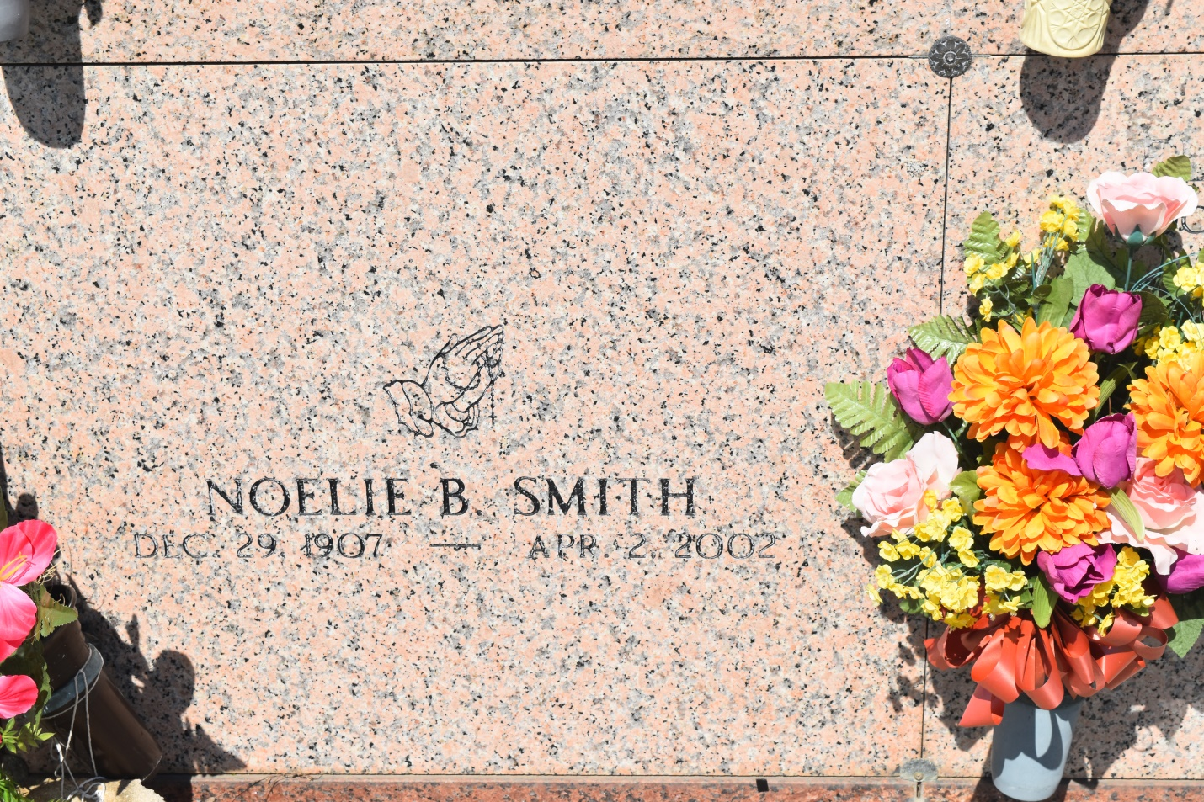

Noelie Boudoin Smith, a homemaker, died April 2 at Riverlands Health Care in Lutcher. She was 94. Mrs. Smith was a lifelong resident of Edgard. Survivors include a son, Bertrand Hilaire Sr. of Hahnville; three daughters, Audrey Oubre, Grace Cook and Dolores Cox; 28 grandchildren; 38 great-grandchildren; and six great-great-grandchildren.

A Mass will be said Monday at 11 a.m. at St. John the Baptist Catholic Church in Edgard. Visitation will begin at 8 a.m. Burial will be in the church cemetery. Baloney Funeral Home is in charge of arrangements.

Times-Picayune, The (New Orleans, LA) - Sunday, April 7, 2002

Contributed by Jane Edson