Leroy David Sorapuru

November 8, 1934 – April 21, 2008

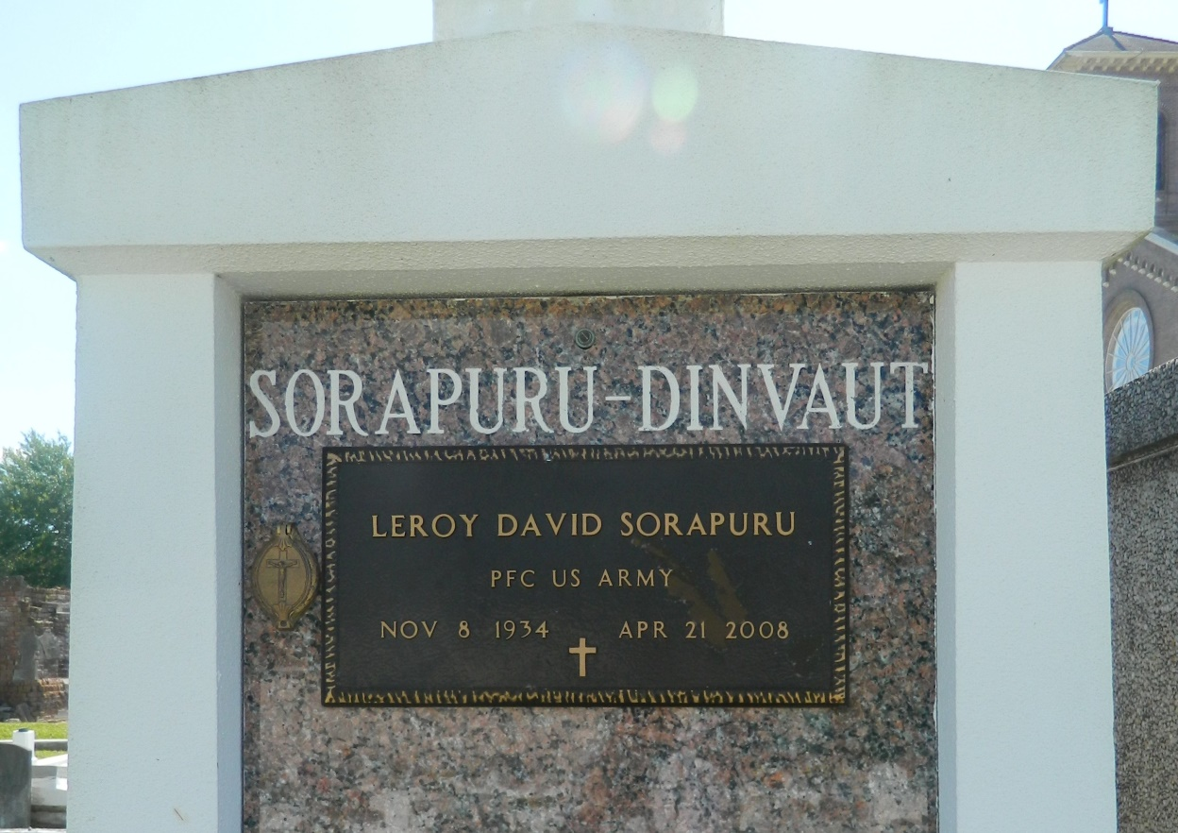

Leroy David Sorapuru entered into eternal rest on April 21, 2008 at the age of 73. Son of the late Wilbert and Honorine Sorapuru. He is survived by his loving wife of 51 years, Rosemary Dinvaut Sorapuru, daughter Monique S. Cook (Silas Jr.), and son Fabian S. Sorapuru (Treneice). Grandfather of Kelli Cook-Morrell (Nicholas), Laure Cook, Tyrania, Feagin, Breion, Dustin, Kiya Sorapuru, and Landis Wilson. Great-grandfather of Paris Isom. Beloved brother of Larry Sorapuru, Sr. (Grace), Bertha Sorapuru, Olga Boudoin (late Lynn), Theresa Adam (late Andrew), Audrey Gauthier (late Perry), late Thelma S. Barre, late Stanley Sorapuru (Dolorous), and the late Wilbert Sorapuru, Jr. (late Dorothy). Brother-in-law of Rudolph Dinvaut (late Corrine), Ferdinand Dinvaut III (Philomena), Jacquline Rousseve (late Maurice), Beverly Harris (Yale), and the late Mullin Dinvaut. Also survived by a host of nieces, nephews, other relatives and friends.  
  
Relatives and friends of the family are invited to attend a Mass of Christian Burial on Saturday, April 26, 2008 at 11:00 a.m. from St. John the Baptist Catholic Church, 2361 Hwy. 18, Edgard, La. 70049. Visitation will be held from 9:00 a.m. - 11:00 a.m. Recitation of the Rosary at 10:00 a.m. Reverend Joel Cantones, Celebrant. Interment St. John the Baptist Catholic Cemetery.  
  
Arrangements by The Baloney Funeral Home, LLC.

Times-Picayune, The (New Orleans, LA) - Friday, April 25, 2008

Contributed by Jane Edson