Rudolph Solomon Sorapuru

February 20, 1927 – November 14, 2007

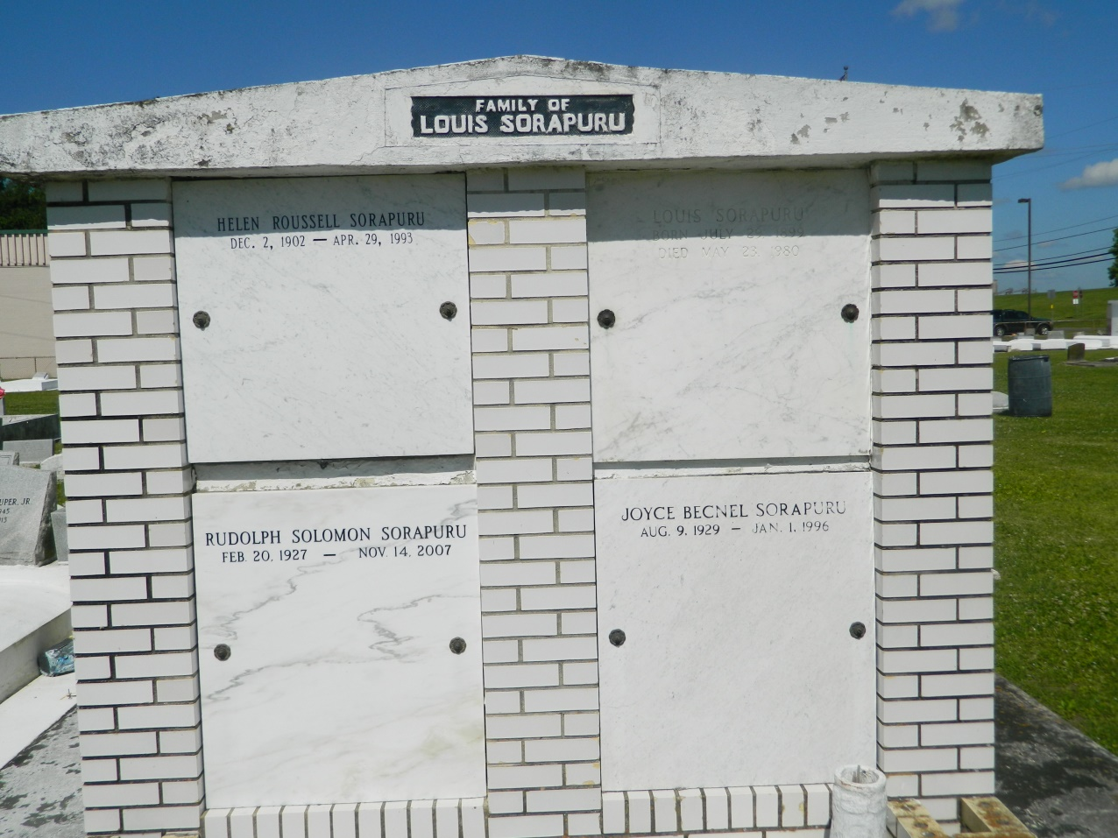

Rudolph Solomon Sorapuru, Sr. died on Wednesday, November 14, 2007 at East Jefferson Hospital. Beloved husband of the late Joyce Becnel Sorapuru. Son of the late Louis and Helen Sorapuru. Father of Tanya Haydel and Rudolph (Tammy) Sorapuru. Brother of Russell (Theresa) Sorapuru and the late Marion Barre. Grandfather of Marius Haydel, Dustin and Jamiah Sorapuru, Tessie Nicholas and Lacey Bailey. Also survived by 5 great grandchildren and a host of nieces, nephews, cousins, other relatives and friends.  
  
Relatives and friends of the family, also employees of Gaudet High School, St. John the Baptist Parish Police Jurors, St. John Parish Sheriff Department, Walmart Supercenter, Rouse Supermarket, Metro Gaming Room (Poker Palace) and Off Track Finish Line are invited to attend the Funeral Mass of Christian Burial at St. John the Baptist Catholic Church, Hwy. 18, Edgard, LA, on Tuesday, November 20, 2007 at 11:00 am. Visitation will begin at 9:00 am. Interment: Church Cemetery. Arrangements by DW Rhodes Funeral Home, Gretna, LA. Please visit [www.rhodesfuneral.com](http://www.rhodesfuneral.com/) to sign the guest book.

Times-Picayune, The (New Orleans, LA) - Sunday, November 18, 2007

Contributed by Jane Edson