Annette (Simon) St. Pierre

February 1, 1910 – August 31, 2000

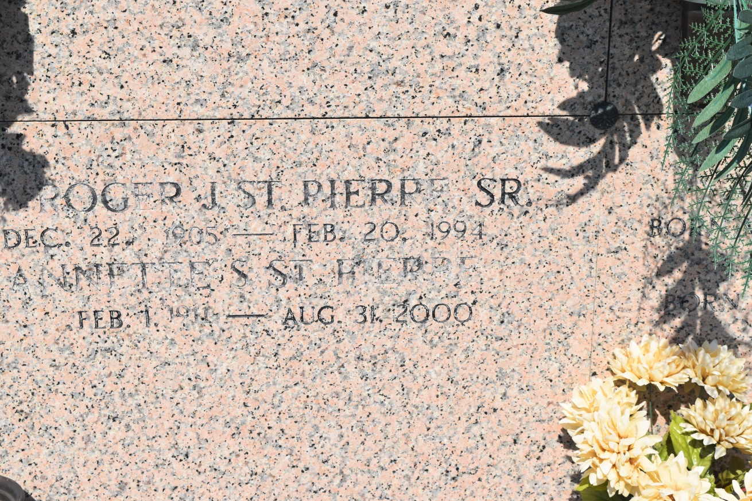

EDGARD - Annette Simon St. Pierre, 89, a native of Vacherie and resident of Edgard for 64 years, died Aug. 31. She was the wife of the late Roger St. Pierre Sr. and mother of Roger Jr. and the late Rodney St. Pierre Sr. She was also the daughter of the late Ruffin and Herminie F. Simon and sister of the late Earisie Schexnayder and Lionel, Megilde, Dano, Horace and Ruffin Simon.  
  
She is survived by four grandchildren and four great-grandchildren. She was preceeded in death by one grandchild.  
  
Services were Sept. 2 at St. John the Baptist Catholic Church, Edgard, with interment at the church cemetery.

L'Observateur (La Place, LA) - Wednesday, September 6, 2000

Contributed by Jane Edson