Dana A. Stipe

December 23, 1976 – September 7, 2004

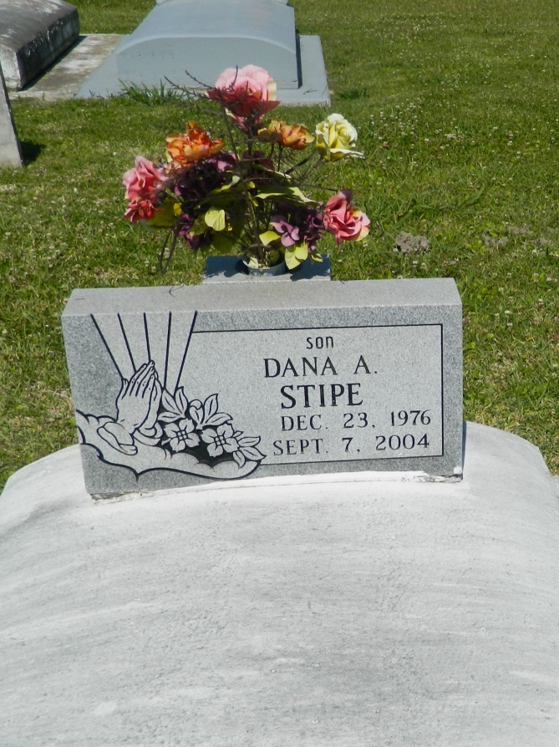

Dana Stipe died Tuesday of multiple gunshot wounds in the 1400 block of South Dilton Street in Metairie. He was 27. Mr. Stipe was born in New Orleans and lived in Edgard. Survivors include a son, Jalen Antoine; his father, Michael Borne Sr.; his mother, Cheryl Stipe; two brothers, Michael Borne Jr. and Christopher Johnson; three sisters, Donyell and Genice Stipe, and Nicole Jones; and his grandmothers, Georgiana Stipe and Claire Borne. A funeral will be held Monday at 11 a.m. at Canaan Baptist Church, 319 Killona Drive, Killona. Visitation will begin at 9 a.m. Burial will be in St. John the Baptist Cemetery in Edgard. Robottom Mortuary in Reserve is in charge of arrangements.

Times-Picayune, The (New Orleans, LA) - Sunday, September 12, 2004

Contributed by Jane Edson