Bertha Sylvain

1921 – May 14, 2018

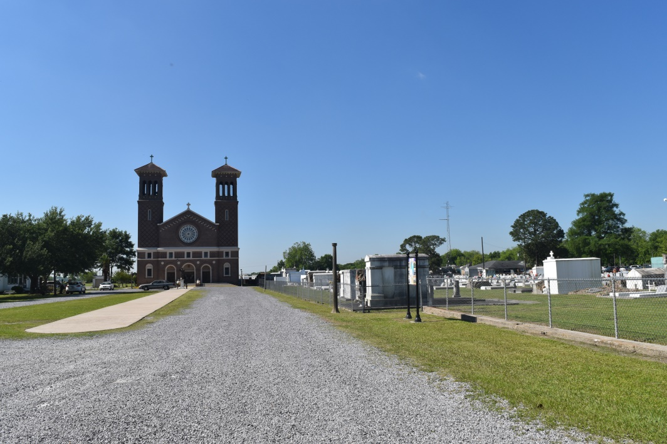

Bertha Sylvain of Edgard, La. Monday May 14, 2018 at Luling Living Center departed this earthly life. Daughter of the late Joseph and Albertine Sylvain. Sister of the late Joseph, Orelia, Corrine, Lionel Sylvain. Devoted aunt of Warner (Sandra), Donald (late Maxine), Michael (Edna), Ferdinand (Barbara), Robert (Dora), and the late Rudy (Audrey). Also survived by a host of great and great great nieces, nephews, other relatives and friends. Relatives and friends of the family also priest and parishoners, of St. John the Baptist Catholic Church, employees of Luling Living Center are invited to attend a mass of Christian burial on Saturday May 19,2018 at 11:00am from the St. John the Baptist Catholic Church 2349 Hwy,18 Edgard, La. Father Robustiano Morgia celebrant. Visitation at the church after 9:00am, Recitation of the rosary 9:30am. Entombment church mausoleum. Final care entrusted to Treasures of Life Funeral Services. 315 E. Airline Hwy. Gramercy, La. 70052  
“When someone you love becomes a memory that memory becomes a TREASURE”

Treasures of Life Funerals online obit (accessed 6/19/2018)