Canedia C. (Rousseve) Thomas

August 11, 1939 - October 2, 2020

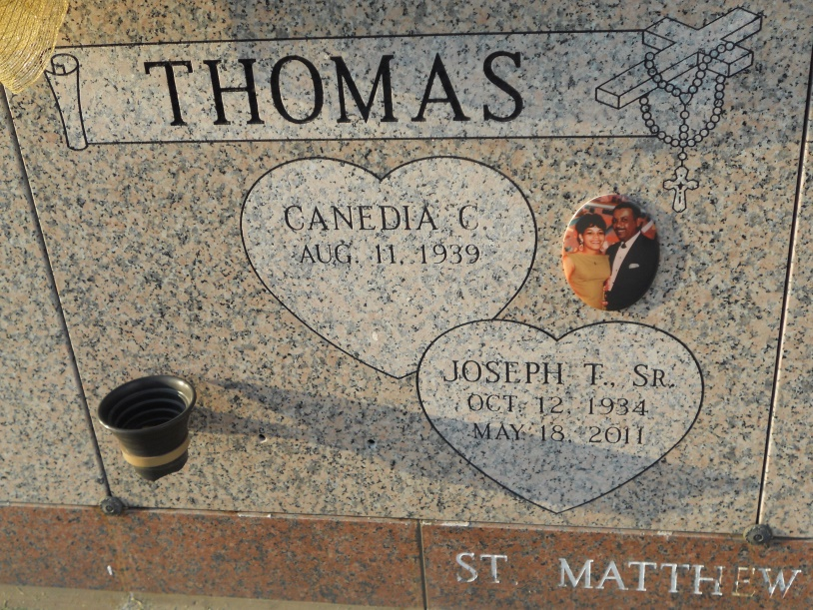 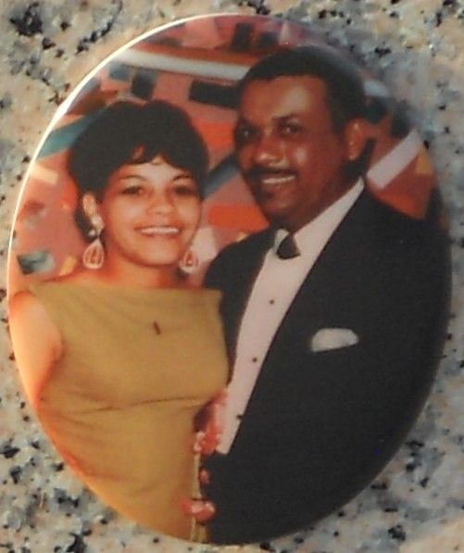

Photos by Team T-Lo

Canedia Rousseve Thomas on Friday, October 2, 2020 at Luling Living Center, Luling, LA. Daughter of the late Rose Duronslet and Lionel Rousseve. Beloved wife of the late Joseph T. Thomas, Sr. Mother of Michelle A. Thomas and Joseph T. Thomas, Jr. Sister of Iris R. Sears (John), Ruby R. Coustaut, Emile M. Rousseve (Leah), the late Maurice Rousseve, Sr. and Charles Rousseve. Grandmother of Alaya Thomas. Also survived a host of nieces, nephews, other relatives and friends. Age 81 years. A native and a resident of Edgard, LA. A private Funeral Mass was held at St John the Baptist Catholic Church, 2349 Highway 18, Edgard, LA on Friday, October 9, 2020 at 10:00 am. Fr. Robustiano Morgia, Celebrant. Interment St John the Baptist Cemetery, Edgard, LA. Visitation at the above named church from 9:00 am until Mass Time. Recitation of the rosary at 9:30 am. Serviced by Robottom.

Published in The Times-Picayune from Oct. 10 to Oct. 11, 2020.