Emelda (Louis) Thomas

March 30, 1926 – February 6, 2007

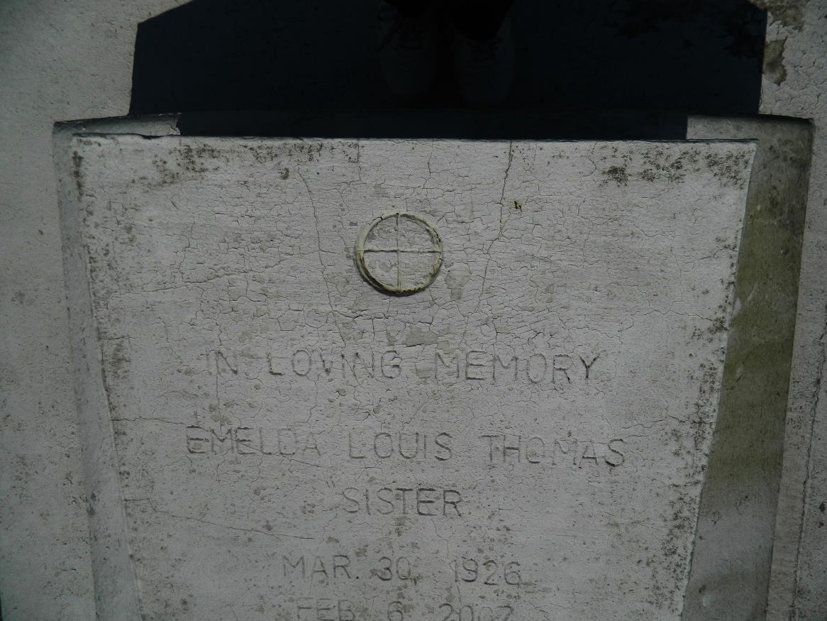

Emelda C. Louis (Sister) Thomas, of Edgard, LA at Canon Hospice on Tuesday, February 6, 2007. Daughter of the late Emelda Pierre Louis and Fergust Louis. Wife of the late Phillip Thomas. Mother of Earl (Selina), Joseph (Torrin) Thomas, and the late Phillip and Norman Thomas. Brother of Doretha and Audrey Fredrick, Stafford Louis and the late Roland Joseph and Ferguson Louis. Also survived by 6 grandchildren, 7 great grandchildren, a host of nieces, nephews, cousins and friends. Age 80 years, a native and resident of Edgard, LA.  
  
Relatives and friends of the family, also Priest and Parishioners of St. John the Baptist Catholic Church, Edgard, LA are invited to attend a Mass of Christian Burial on Saturday, February 10, 2007 at 11:00 a.m. from the St. John the Baptist Catholic Church, Edgard, LA. Father Joel Cantones Celebrant. Interment Church Cemetery. Visitation at the church after 9:00 a.m.  
  
THE BALONEY FUNERAL HOME, L.L.C., 399 Earl Baloney Dr. Garyville, LA 70051,   
985-535-2540 In charge of arrangements

Times-Picayune, The (New Orleans, LA) - Friday, February 9, 2007

Contributed by Jane Edson