Geraldine (Duronslet) Thomas

January 20, 1931 – August 22, 2008

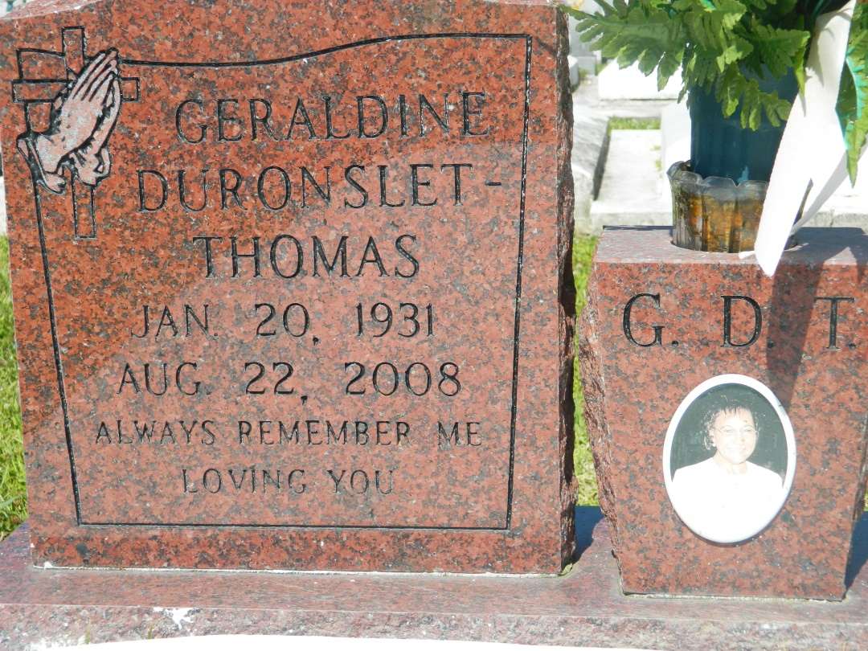

Geraldine Duronslet Thomas died peacefully at her Marrero LA home on Friday, August 22, 2008 at 3:10 PM. She was 77 years old. Daughter of the late Elizey and Bertha Louper Duronslet Sr. Wife of the late Bennie Thomas. Always Mom to Rogers Washington, Rose Smith, Chrystal Comiere, Sandra Harris, Darlene Coachman, Marilyn Edwards, Bertha Evans, Nadine Gauthier, Aline "Yvette" Johnson and the late Emile Washington III. Sister to Delphine Young, Sedonia Mitchell, Sheral Isom, Clifford Duronslet and the late Robert Duronslet Sr., Thelma Joseph, and Elizey Duronslet Jr.  
  
Relatives and friends of the family along with the Priest(s) and Parishioners of Holy Guardian Angle Catholic Church, St John The Baptist Catholic Church and neighboring churches are invited to attend a Christian Burial Mass at St. John The Baptist Catholic Church, Edgard, LA on Friday, August 29, 2008, at 11:00 AM , Father Joel Cantones and Reverevd Msgr. J. Anthony Luminais, Celebrant. Interment, Church Cemetery. Visitation at the above named church, 9:00 AM until Mass begins.  
  
The Baloney Funeral Home LLC, 399 Earl Baloney Drive, Garyville, LA 70051, (985) 535-2540

Times-Picayune, The (New Orleans, LA) - Thursday, August 28, 2008

Contributed by Jane Edson