Philip Thomas Jr.

May 19, 1947 – June 12, 2005

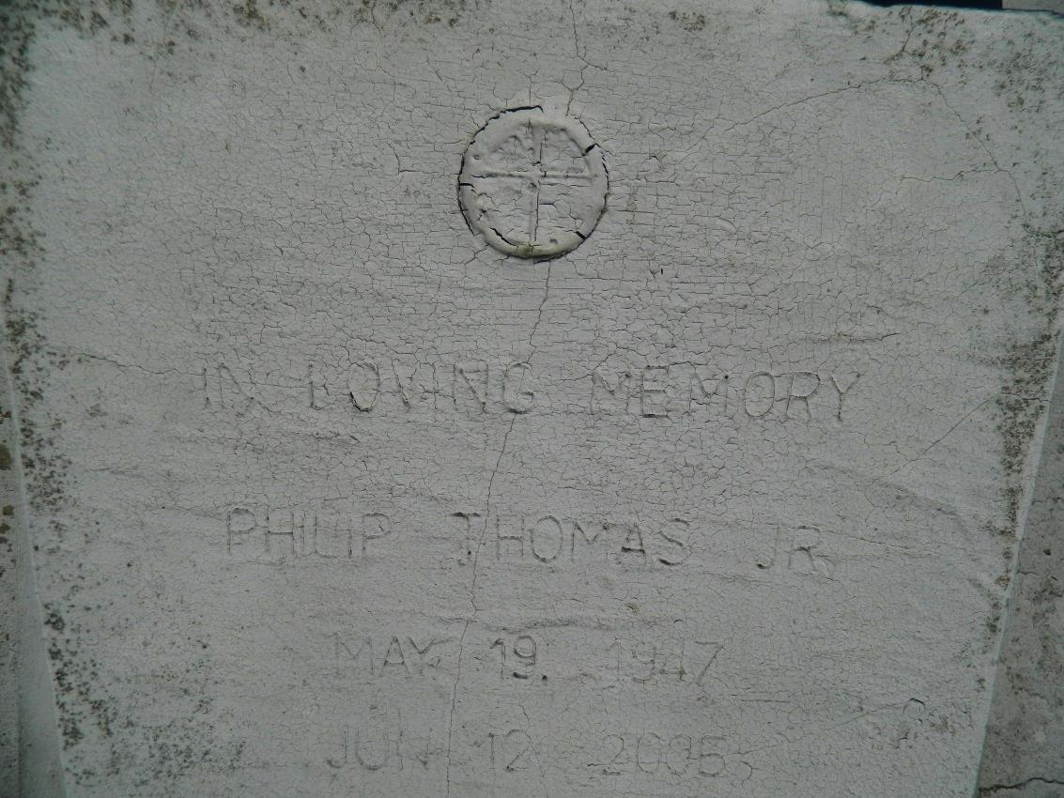

Philip Thomas Jr., a retired farmhand at Goldmine Plantation, died Sunday of cancer at East Jefferson General Hospital. He was 58. Mr. Thomas was a lifelong resident of Edgard. He was a member of the St. John the Baptist Catholic Church Altar Society.

Survivors include his mother, Emelda Thomas, and two brothers, Earl and Joseph Thomas.

A funeral will be held today at 11 a.m. at St. John the Baptist Catholic Church, 2349 Louisiana 18, Edgard. Visitation will begin at 9 a.m. Burial will be in the church cemetery. The Baloney Funeral Home is in charge of the arrangements.

Times-Picayune, The (New Orleans, LA) - Saturday, June 18, 2005

Contributed by Jane Edson