Dale Ray Thompson

February 20, 1944 – June 24, 2001

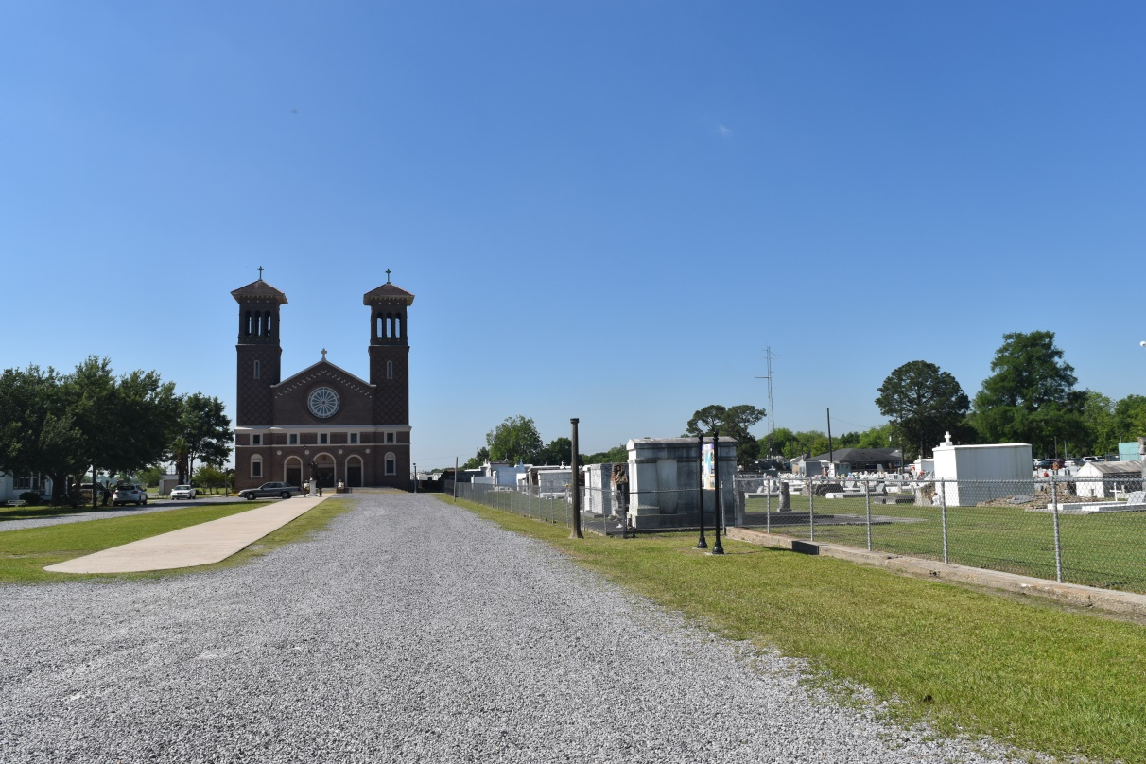

Dale Ray Thompson, a heavy-equipment operator, died Sunday of a heart attack at his home in Norco. He was 58. Survivors include a son, Michael Thompson of Norco; two daughters, Crissy Thompson of Paradis and Melanie St. Pierre of Texas; two brothers, Melford Thompson and Charles Thompson of Lake Charles; a sister, Helen Pittman of Florida; and four grandchildren.

A funeral will be held Saturday at 10 a.m. at Millet Guidry Funeral Home, 2806 Airline Highway, LaPlace. Visitation will begin at 8 a.m. Burial will be in St. John Cemetery in LaPlace. Millet-Guidry Funeral Home is in charge of arrangements.

Times-Picayune, The (New Orleans, LA) - Friday, June 29, 2001

Contributed by Jane Edson