Bottom of Form

# Desmond Dural Walker

August 20, 1973 - March 7, 2022

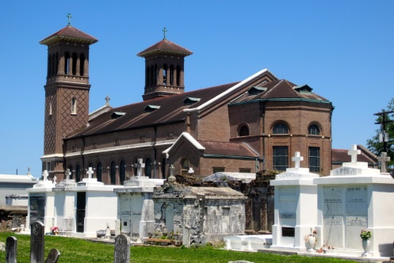

On Monday, March 7, 2022, at Ochsner Medical Center in New Orleans, LA,**Desmond Dural Walker**, at the age of 48, entered his eternal rest, joining his loving mother, the late Marsha A. Walker. Born on August 20, 1973, Desmond was raised in Lucy by his mom in the loving home of his grandparents, the late Joseph, and Melba Alexander Walker.

A proud graduate of West St. John High School's Class of 1991, he went on to play college football and further his education at a university in Kansas and later at Southern University in Baton Rouge, LA.

Years later, Desmond met and married his loving wife Joland Brown Walker in 2004, where they shared a new home in Reserve, LA, and welcomed and entertained a host of family, friends, and fellow church members until his passing. Desmond was a member of and later an Elder at Fresh Faith Worship Center in Destrehan, LA. He was employed by ADM in 2008 as an Operator and was later promoted to Supervisor where he remained employed until he became disabled.

Desmond enjoyed a loving and special relationship with his father Paul (Tonette) Bailey and sister Tawanda (Ondrell) Moore, which they nurtured until his passing.

Desmond leaves to cherish his memories his loving wife Joland Brown Walker, father Paul and sister Tawanda, uncles, Nathaniel (Mary  Ann) Walker, Grant (Jacqueline) Walker; aunts, Mary Walker, Margo  (Helmond) Lumar, Demetre (Kerry) Bailey, parents-in-law James and Melva Brown, sisters-in-law Jandrell, Janettra, and Jamilyn Brown, Jovanna (Joshlee) Diggs, and brothers-in-law James, Jr and Jerrian Brown.

He was preceded in death by his mother, Marsha A Walker, grandparents Joseph and Melba Walker, uncle, Lynwood Walker, aunt, Avis Jessie, and cousin, Rachelle Walker. He will be sadly missed by his family, a host of cousins, relatives, friends, church members, classmates, and former co-workers.

Relative and friends of the family, as well as church and community members are invited to attend a Funeral Mass of Christian Burial, Friday, March 18,2022, at 11:00 am, at Greater Good Hope Baptist Church,47 Cathy Street, Norco, LA. Visitation will begin at 9:00am. Interment at St. John the Baptist Catholic Church Cemetery, 2349 LA-18, Edgard, LA. Arrangements entrusted to Patrick Sanders Funeral Home, 605 Main Street, LaPlace, LA.

**The Patrick H. Sanders Funeral Home, LaPlace, Louisiana**