Camille (Alfred) Weber

March 17, 1921 – June 6, 2008

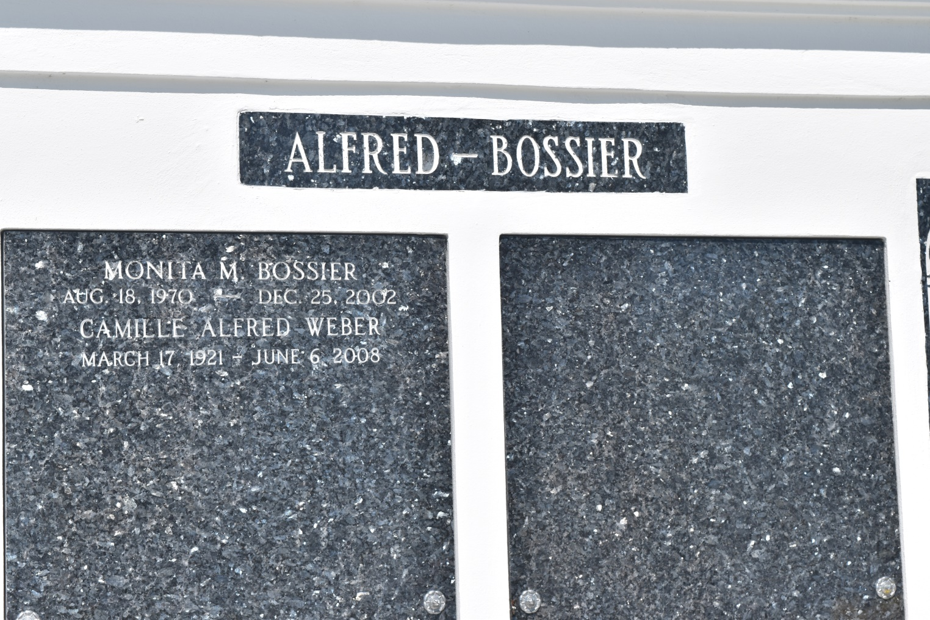

Camille Alfred Weber departed this life on Friday, June 6, 2008, in Nesbit, MS, at the age of 87. Wife of the late Joseph Robert Weber. Daughter of the late Fergus and Clarice Chaligny Alfred. Sister of Bonita (Felix) James, Memphis, TN and the late Alice Alfred Burham. Mother of Kenneth James, Memphis, TN, Paula Bossier Miller, Walled Lake, MI, Bonita Bossier Bazil, Lafayette, LA and John (Angelique) Bossier, Nesbit, MS. Grandmother of Monique (Carl) Moody, William (Shonita) Bossier, Raequel Miller, Phoebe Miller, Cedric Walker, Chaligny Millon, Megan Bossier, and the late Monita Bossier. Also survived by four great-grandchildren.  
  
She was a retired Licensed Cosmetologist and Licensed Practical Nurse and a former resident of Edgard, LA, Detroit, MI and New Orleans, LA.  
  
Relatives, friends of the family, former residents and staff of Delille Inn, employees of Catholic Charities of Detroit, Orleans Parish School Board, University of Tennessee Health & Science Center, Nike, Inc., and members of Omega Psi Phi Fraternity, Inc. are invited to attend a Mass of Christian Burial on Saturday, June 14, 2008, 11:00 a.m., at St. John the Baptist Catholic Church, 2361 Hwy. 18, Edgard, LA. Visitation prior to service beginning at 9:00 am. Reciting of the Rosary at 10:00 am. Interment in church mausoleum. Visitation will also be held on Friday evening, June 13, 2008, from 4:00 p.m. - 6:00 at Majestic Mortuary, 1833 Oretha Castle Haley Blvd., New Orleans, LA.  
  
Services entrusted to: Majestic Mortuary Services, (504) 523-5872.

Times-Picayune, The (New Orleans, LA) - Friday, June 13, 2008

Contributed by Jane Edson