Dolores (Jarrow) Weber

December 7, 1928 – June 21, 2000

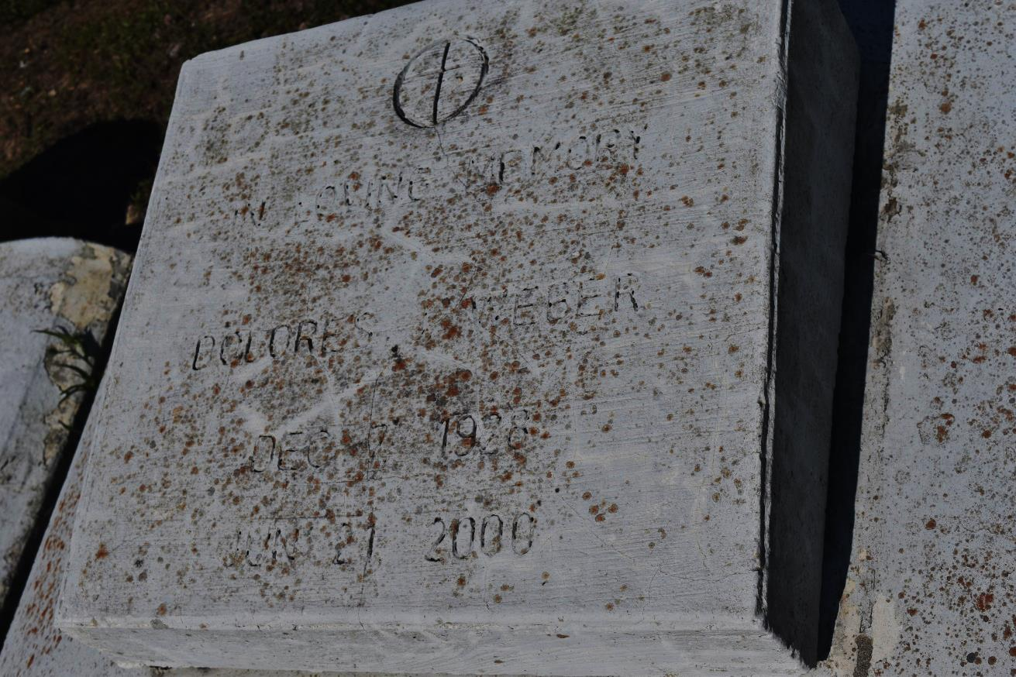

EDGARD - Dolores "Dalo" Jarrow Weber, 71, a resident of Edgard, died June 21. She was the wife of the late Antoine Weber, mother of Mary Francois, Sheryl Williams, Gwendolyn Narcisse, Martin Weber and the late Marilyn Weber and guardian of Terrill Weber and Charles Francois Jr.  
  
She was also the daughter of the late Gregory and Georgiana Jarrow and sister of Octavia Daniels, Francis Turner, Theresa Alexander, Wilbert, Mary, Jerry, Nova and Lucien Jarrow and the late Louverther Boudoin.  
  
She is also survived by five grandchildren and three great-grandchildren.  
  
Services were June 26 at St. John the Baptist Catholic Church, Edgard, with interment at the church cemetery.

L'Observateur (La Place, LA) - Tuesday, June 27, 2000

Contributed by Jane Edson