John Allen Wright

August 10, 1925 – December 5, 2004

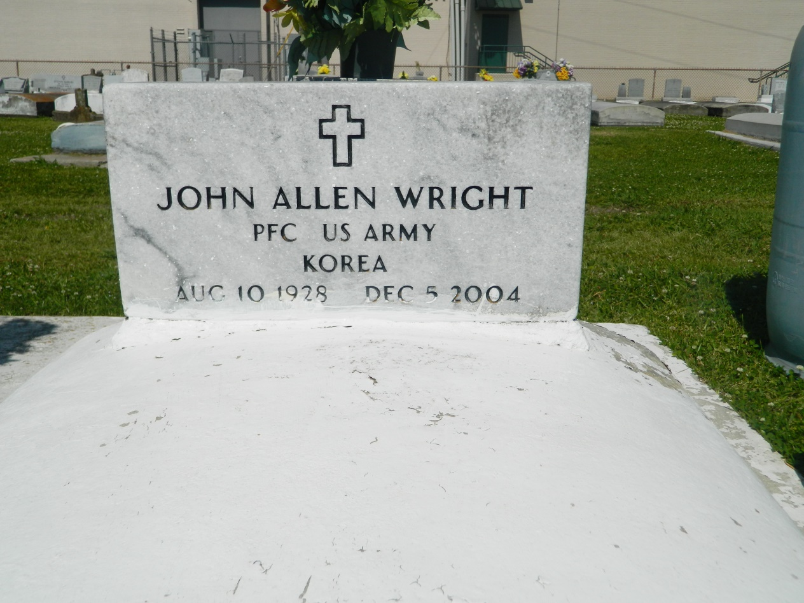

EDGARD - John Allen "Big Al" "Big Time" Wright Sr., 76, a native of Mobile, Ala., and resident of Edgard, died Dec. 5.  
  
He was the husband of Orella Jasmine Wright and father of Betty Franklin, Valerie Wright, Alicia London, John Jr., Mark "Jo-Jo," and David Wright, and the late Cheri Fields, and stepfather of Levern Jack and Antoine Jasmine.  
  
He was also the son of the late David and Bessie Wright, and brother of Velma Sanders and Charles Wright. He is preceded in death by two brothers and one sisters.  
  
He is also survived by 17 grandchildren and four great-grandchildren.  
  
Services are today at 11 a.m., at St. John the Baptist Catholic Church, Edgard, with interment at the church cemetery. Visitation starts at 9 a.m.

L'Observateur (La Place, LA) - Tuesday, December 14, 2004

Contributed by Jane Edson