Charles Isadore Young

February 14, 1929 – July 13, 2006

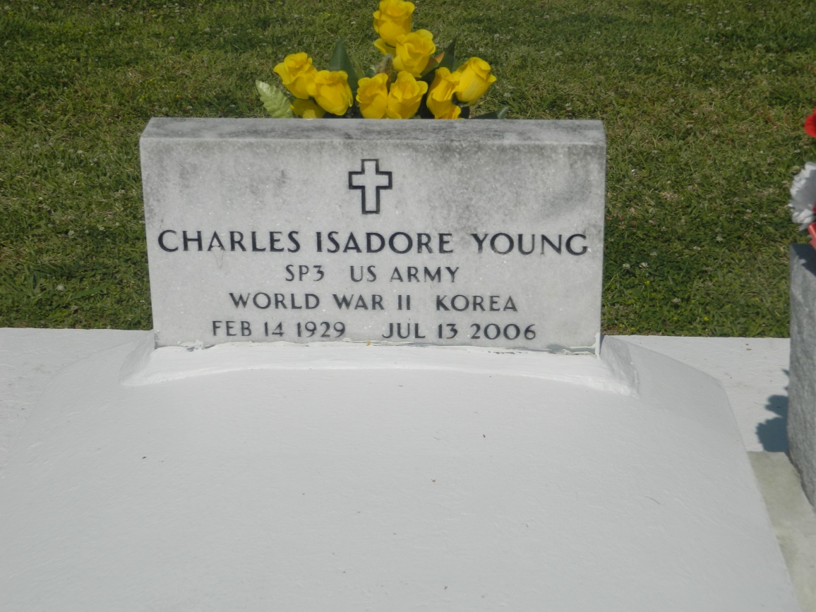

Charles Isadore Young - Aged 77, Peacefully departed this life on July 13, 2006 at 1:15 a.m. at his resident. Son of the late Mack Young and the late Sylvia Laura Pierre Young a native of Vacherie, LA and a resident of Bridge City, LA for over fifty years, loving and devoted husband of Delphine Duronsiet (sic – Duronslet) Young for 50 years.  
  
Father of Charels, Jr., Linda Young Blazio; Gilda (Leon) Sneed; Anthony (Deborah); Darrell (Vera); and Todd (Trina) Young; and Pamela (Roosevelt) Carter. Two sisters: Anita Y. Kennedy and Agnes Bernice Y. Cooper of Los Angeles, CA, and the late Milton Young, Mildred Y. Johnson, and Clara Y. Hamilton; 6 brothers-in-laws, 6 sisters-in-laws, 22 grand children, 15 great grand children, 6 god daughters, and a host of nieces, nephews, other relatives and friends.  
  
Relatives and friends of the family also, priests, pastors and parishioners of Holy Guardian Angels Catholic Church, Third Emanuel Baptist Church and all neighboring churches of Bridge City, LA; New Home Ministries of New Orleans, LA; St. John The Baptist Catholic Church, Edgard, LA; Gethsemane Missionary Baptist Church of Houston, TX and Our Mother of Mercy Catholic Church, Houston, TX. Employees of Avondale Shipyard, Children's Hospital, Evans Travel Agent, East Jefferson General Hospital, West Jefferson Medical Center, South Eastern Freight Lines, Wal-Mart of Algiers, Harrahs Casino, FKP Architects, Inc. and March of Dimes of Houston, TX.  
  
The family wishes to express special thanks to Dr. Castillo and the Staff of Ochsner Medical Institution's Oncology Department, Serenity Hospice Services of Jefferson Parish, and Friends from Houston are invited to attend a Mass of Christian Burial at Holy Guardian Angels Catholic Church, 1701 Bridge City Avenue, Bridge City, LA on Wednesday, July 19, 2006 at 11:00 a.m. Recitation of the Rosary at 10:30 a.m. Celebrant Officiating Msgr. J. Anthony Luminais. Interment at St. John The Baptist Catholic Church Cemetery, 2361 Hwy 18, Edgard, LA.  
  
Arrangements by DAVIS MORTUARY SERVICE, 230 Monroe Street, Gretna, LA.

Times-Picayune, The (New Orleans, LA) - Tuesday, July 18, 2006

Contributed by Jane Edson