Delphine Marie (Duronslet) Young

December 24, 1932 – September 2, 2017

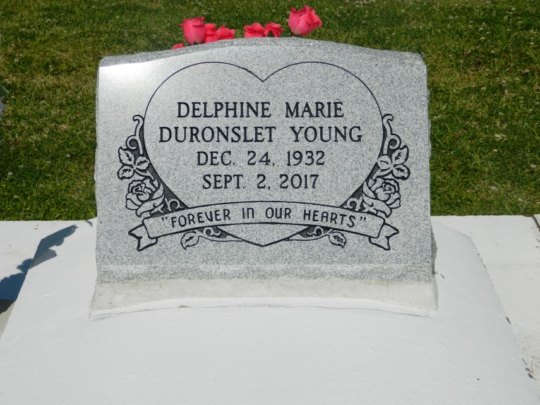

Bottom of Form

Delphine Marie Duronslet Young departed this life at her residence on Saturday, September 2, 2017, surrounded by her loving family. She was a native of Lucy, LA and a resident of Bridge City, LA. Devoted wife of 50 years to the late Charles I. Young. Loving mother of Gilda Young (Leon) Sneed of Houston, TX, Anthony M. (Deborah) Young, Darrell J. (Vera) Young, Pamela Young (Roosevelt) Carter, and Todd M. (Tobi) Young all of Marrero, LA. Stepmother of Charles Young of Bridge City, LA. Daughter of the late Elizey, Sr. and Bertha Louper Duronslet. Sister of Sedonia D. Mitchell of New Orleans, LA and Sheral D. Isom of Edgard, LA. Sister-in-law of Lily Mae Ruby Young of Detroit , MI, Mae Rose Duronslet of Gulfport, MS, Gladys Duronslet of Laplace, LA, Murphy Isom, Jr. of Edgard, LA, and Deacon James Hamilton of Phoenix, AZ; also survived by 13 grandchildren, 10 great grandchildren, and a host of godchildren, nieces, nephews, cousins, other relatives and friends, and friends of Houston. Relatives and friends of the family, also priest and parishioners of Holy Guardian Angels Catholic Church, St. John the Baptist Catholic Church, Our Mother of Mercy Catholic Church of Houston, TX; pastors, officers, and members of Gethsemane Baptist Church of Houston, TX, Third Emanuel Baptist Church, and all neighboring churches; employees of Ochsner Medical Center, Children's Hospital, Wal-Mart (Algiers), John E. Koerner, and Harrah's Casino are invited to attend the Mass of Christian Burial at Holy Guardian Angels Catholic Church, 1701 Bridge City Ave., Bridge City, LA on Saturday, September 9, 2017 at 10:30a.m. Msgr. Allen Roy, celebrant. Visitation will begin at 8:30a.m. until service time at the church; Recitation of the Rosary 9:30a.m. Interment: St John the Baptist Catholic Church Cemetery-Edgard, LA. Arrangements by Davis Mortuary Service, 230 Monroe St., Gretna, LA.

Published in TheNewOrleansAdvocate.com from Sept. 7 to Sept. 9, 2017